Generate PDF and PNG contours

* **Problem:**

The details provided by the kmz and kml file are too few: the profile is not sharp enough to identify the boundaries/contours of constant concentration. The change of colors is not continuous. The program itself is less powerful than the Matlab built-in functions “contour” and “contourf”.

* **Solution:**

Use matlab built-in function contourf() to generate the contours, and save them into PDF and PNG files, which will be sent to users by email.

* **Steps of generating contours using matlab:**

1. Read the data from the temp file “conc_dep_data.txt”, which contains all the information needed to calculate the “concentration”, “deposition” and “outcrossing” contours， the format of the output data are as follows;

DAY HR LAT LON DEP CON OUT

204 9 36.19 -86.69 2.50e-03 4.40e-05 7.50e-11

204 9 36.20 -86.69 8.70e-03 1.40e-04 2.61e-10

。。。。。。

In it, “LAT” means Latitude，”LON” means Longitude， “DEP” means Deposition(grains/m2)，”CON” Concentration(grains/m3) and “OUT” means Outcrossing;

1. Generate the mesh matrix by separating the map range into 200x200 cells;

* The number of the mesh cells is important, if it is too few(for example, 40X40), the source location inputted by use could be cut off during meshing process when it is on the boundary of the map range, that will caused the source location out of the contours. If it is too many, the computing performance will be poor, so we choose 200X200 as a tradeoff, and it can let the source location is enough close to the contours. See the following contours generated using 40x40 mesh and 400x400 mesh.

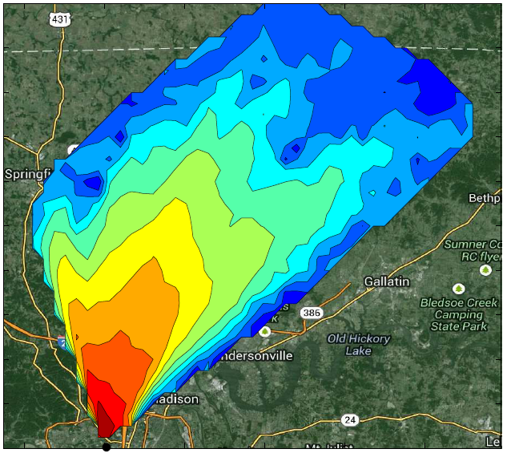 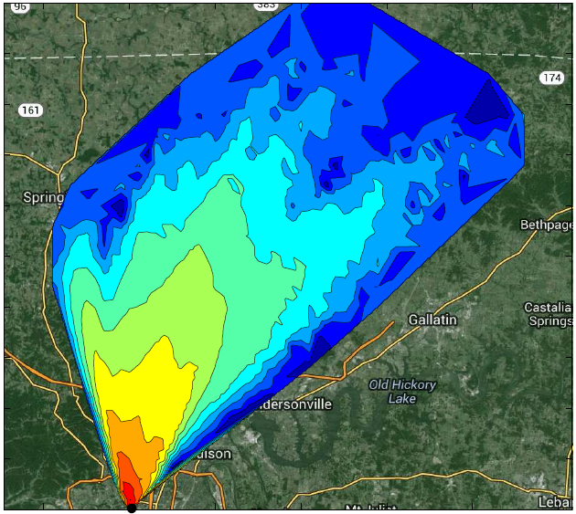

（40x40） (400x400)

1. Interpolate the existing deposition data to get the deposition value for all the mesh point；

* Matlab provides five kinds of interpolation method. Among them, the methods “linear” and “natural” are both suitable for our needs. But linear method may generate wrong data on the boundary sometimes, so we choose the “natural” method. See the following figures for the comparation.

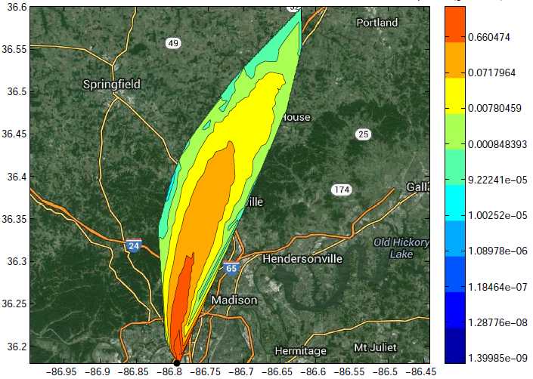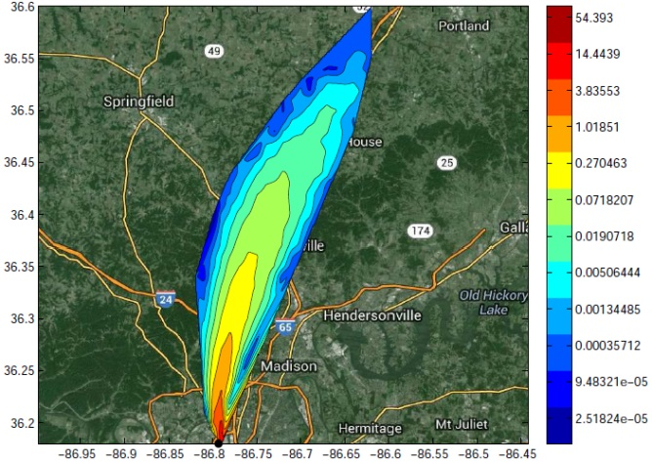

Linear Natural

* In the output file, the concentration value may be zero. Because we use log10() function to calculate the color range, log10(0) will get “-infinite”. So we have to figure out a way to handle with “0” . Our method is to find the smallest concentration value except for “0”, then set all the “0” into “the smallest value divided by 100”.

1. Generate the filled contour using the mesh data, plot the source location on the map and plot the google map as the background;
2. Output the contours into pdf and png file.

I attached the matlab codes as appendix, please review if you need more details.

* **How to Generate .exe file from .m file?**

After writing the matlab .m file, we can convert .m file into an .exe file using the matlab deployment tool, so the php file can call it using command even if no matlab environment is available.

1. Type “>>deploytool” at the matlab command prompt to launch the matlab deployment tool. The matlab version we are using is R2012B, the corresponding compiler runtime is v80.
2. New a project which has name “dco” and has type “windows standalone application”;
3. Add “depconoutcontour.m” as main file;
4. Also add “plot_google_map.m” file as shared resources and helper files;

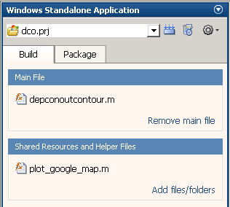 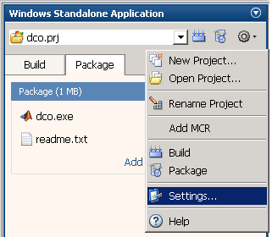 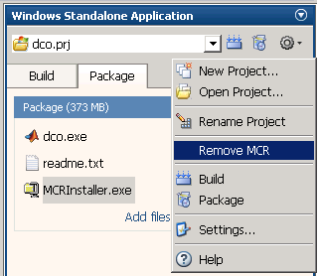

The files The setting location Add/Remove MCR

1. Open the project setting window, check “Embed CTF archive into the Application” in the “General” tab, and check “Disable display” in the “Advanced” tab. Leave the other options as default.
2. Click the build button. After building, you will see the dco.exe file under the distrib folder.
3. You can verify your exe file by typing the following command in the cmd window:

dco.exe sophie 2014-05-01-13.02.53_36.1523_-86.77_ 2 36.1523 -86.77

* **Resource Location:**

1. Matlab .m file:

C:\Program Files (x86)\NMSU\RSET\wwwroot\horseweed\depconoutcontour.m

C:\Program Files (x86)\NMSU\RSET\wwwroot\horseweed\plot_google_map.m

1. Matlab project: C:\Program Files (x86)\NMSU\RSET\dco_project
2. Dco.exe: C:\Program Files (x86)\NMSU\RSET\wwwroot\horseweed\dco.exe

* **Appendix: The codes of matlab function**

function depconoutcontour(userid, filename, flag, lat, long)

% userid: the user id used to find the folder name

% filename: used to name the pdf/png file

% flag: 1-pollen, 2-seed

% lat: the latitude of the source location

% long: the longitude of the source location

close all;

% Load data from the file "conc_dep_data.txt"

A = importdata(['.\', userid, '\conc_dep_data.txt']);

A = A.data;

min1 = min(A);

max1 = max(A);

lat = str2num(lat);

long = str2num(long);

flag = str2num(flag);

h1 = figure();

set(h1, 'Visible', 'off');

% Generate the mesh matrix by separating the location range into 200x200 cells

x = (min1(4)):((max1(4)-min1(4))/200):(max1(4));

y = (min1(3)):((max1(3)-min1(3))/200):(max1(3));

[X,Y] = meshgrid(x,y);

% Interpolate the existing deposition data to get the deposition value for all the mesh point

for i = 1:length(A)

if A(i,5)<1.e-30

I(i) = NaN; % Change all the zero value into "NaN"

else

I(i) = log10(A(i,5));

end

end

Z = griddata(A(:,4),A(:,3),I,X,Y,'natural');

% Generate the filled deposition contour

i1 = min(I); i2 = max(I);

z1 = min(min(Z)); z2 = max(max(Z));

color_range = z1:((z2-z1)/11):z2;

Contours = 10.^color_range;

contourf(X,Y,Z,color_range);

h = contourcmap('jet',...

'Location', 'vertical', ...

'TitleString', 'deposition');

g = colorbar('YTick',color_range,'YTickLabel',Contours);

title(g,'deposition(grains/m2)')

xlabel('longitude');ylabel('latitude');

% Draw the source location on the map

% Sometimes, the source location input by the user isn't included in

% the output map range, so update the source location by finding the nearest location in the output data to the source location.

hold on;

marker_lat = lat;

marker_long = long;

if lat < min1(3)

marker_lat = min1(3);

end

if lat > max1(3)

marker_lat = max1(3);

end

if long < min1(4)

marker_long = min1(4);

end

if long > max1(4)

marker_long = max1(4);

end

plot(marker_long ,marker_lat,'k.','MarkerSize',20);

% plot the google map on the background of the current figure

plot_google_map('maptype','hybrid','APIKey','AIzaSyDMSjokr-3WVHSYtZeW5xM2gI6uO8BkiMI');

% Output the contours into pdf and png file

fileextension = '.pdf';

name = ['.\', userid, '\', filename, 'deposition',fileextension];

print('-dpdf',name);

fileextension = '.png';

name=['.\', userid, '\', filename, 'deposition',fileextension];

print('-dpng',name);

delete(h);

% Similarly, generate the concentration contour

h1 = figure();

set(h1, 'Visible', 'off');

for i=1:length(A)

if A(i,6)<1.e-30

I(i)= NaN;%change all the "0" into "NaN"

else

I(i)=log10(A(i,6));

end

end

imin = min(I);

I(find(isnan(I))) = imin-2;% change all the "Nan" into "min/100"

Z = griddata(A(:,4),A(:,3),I,X,Y,'natural');

z1 = min(min(Z)); z2 = max(max(Z));

color_range = z1:((z2-z1)/11):z2;

Contours = 10.^color_range;

contourf(X,Y,Z,color_range);

h = contourcmap('jet',...

'Location', 'vertical', ...

'TitleString', 'concentration(grains/m3)');

g = colorbar('YTick',color_range,'YTickLabel',Contours);

title(g,'concentration(grains/m3)')

xlabel('longitude');ylabel('latitude');

hold on;

plot(marker_long ,marker_lat,'k.','MarkerSize',20);

plot_google_map('maptype','hybrid','APIKey','AIzaSyDMSjokr-3WVHSYtZeW5xM2gI6uO8BkiMI');

fileextension = '.pdf';

name = ['.\', userid, '\', filename, 'concentration',fileextension];

print('-dpdf', name);

fileextension = '.png';

name = ['.\', userid, '\', filename, 'concentration',fileextension];

print('-dpng',name);

delete(h);

% Finally, generate the outcrossing contour only for pollen

% dispersion

if abs(flag-1)<1.e-6

h1 = figure();

set(h1, 'Visible', 'off');

for i=1:length(A)

if A(i,7)<1.e-30

I(i)= NaN;

else

I(i)=log10(A(i,7));

end

end

Z = griddata(A(:,4),A(:,3),I,X,Y,'natural');

z1 = min(min(Z)); z2 = max(max(Z));

color_range = z1:((z2-z1)/11):z2;

Contours = 10.^color_range;

contourf(X,Y,Z,color_range);

h = contourcmap('jet',...

'Location', 'vertical', ...

'TitleString', 'outcrossing');

g = colorbar('YTick',color_range,'YTickLabel',Contours);

title(g,'outcrossing')

xlabel('longitude');ylabel('latitude');

hold on;

plot(marker_long ,marker_lat,'k.','MarkerSize',20);

plot_google_map('maptype','hybrid','APIKey','AIzaSyDMSjokr-3WVHSYtZeW5xM2gI6uO8BkiMI');

fileextension = '.pdf';

name=['.\', userid, '\', filename, 'outcrossing',fileextension];

print('-dpdf',name);

fileextension = '.png';

name=['.\', userid, '\', filename, 'outcrossing',fileextension];

print('-dpng',name);

delete(h);

end

close all;

end