How to use MS Word Reference Manager

Table of Contents

Add inline citations 2

Edit Inline Citations 5

Add the References section 6

Change the Style of References 8

References 10

As college teachers and students, writing papers is one of your important jobs. When you want to submit your work to a journal or meeting, generally they will provide you a template, all you need to do is to fill up the template that need to be thoroughly researched and properly referenced. Keeping track of all the references you used to write your research paper is not easy, but fortunately for you, MS Word has built-in tool to manage your references.

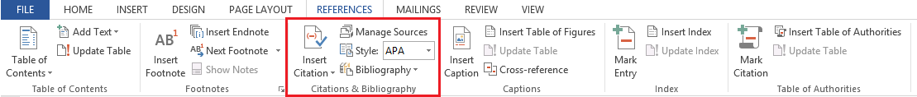

Figure 1. The menu of MS Word reference manager

This guide will show you how to build inline citations and references page quickly and easily. First of all, you need to choose the style of references, see the following figure. MS Word provides several popular styles for you. Generally, the paper template will tell you which reference style you should use, then choose this style. Here, I choose “APA 6th edition” style. You can also change the style after you add all of the references, which will be shown later.

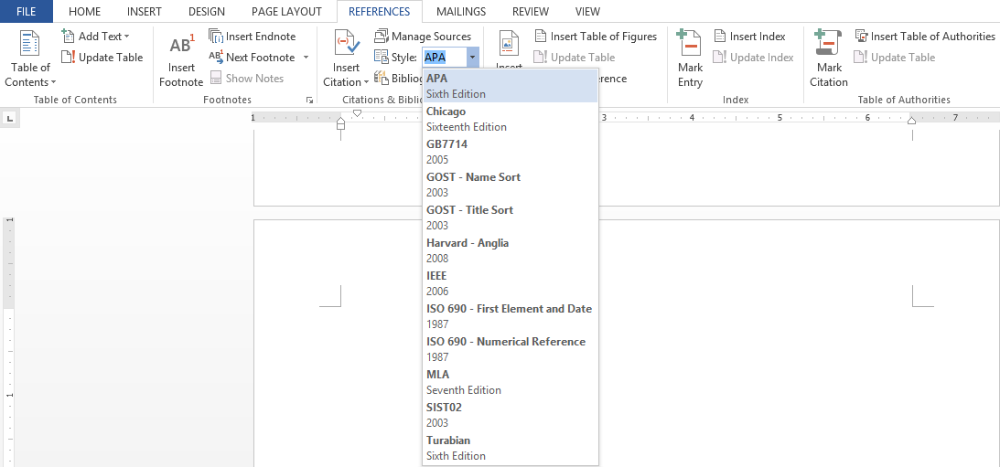

Figure 2. Select the style of references

# Add inline citations

As you use material within the body of your paper, you’ll need to add inline citations to properly attribute your material to the original source. To add a new inline citations, click “REFERENCES->Insert Citation->Add New Source”

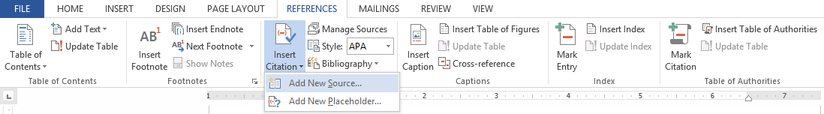

Figure 3. Add a new source

Then the following window will pop up. 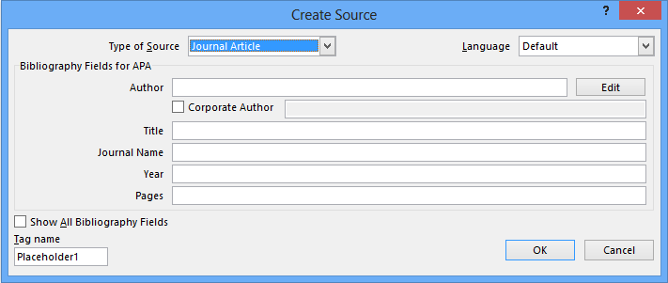

Figure 4. Create source window

All you need to do is to enter the information of your referenced material into the corresponding fields of this window. Firstly, you will need to choose the type of source you’re adding from the drop-down menu. Here, I selected “Journal Article”. Depending on the type of source you choose, MS word will give you different fields, you will see more fields by checking “Show All Bibliography Fields” at the left-bottom corner. See Figure 5.

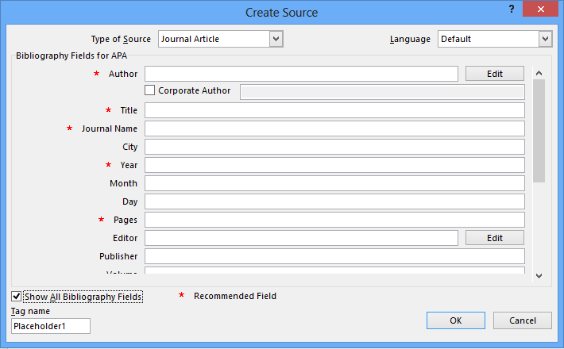

Figure 5. The window of showing all bibliography fields

Then enter the information into the corresponding fields as much detail as possible, click okay to get back to your document. You will see the inline citations inserted at your cursor location. See the following paragraph, which include several inline citations with “APA 6th ed” style.

*“This paragraph isn’t relevant to this document’s content, just be used to demonstrate what inline citations look like. Gene flow via the transfer of GR via pollen, in addition to long-distance seed movement, is troubling because it could aid in the evolution of multiple resistance* (Henry, Davis, & Johnson, 2008)*. Even a single outcrossed plant can produce more than 200,000 seeds* (Weaver, 2001)*,* (Bhowmik & Bekech, 1993)*. Therefore, even with 4% outcrossing (96% self-pollinated), 8,000 outcrossed seeds per plant can be produced. “*

Once you added a source, you can see it in the drop-down menu of “Insert Citation”, so if you want to insert it to somewhere else, you don’t need to create it again, simply point your cursor to the location you’d like the inline citation to go, then click on the source in the drop-down menu, MS word will automatically enter the inline citation at that location. See Figure 6.

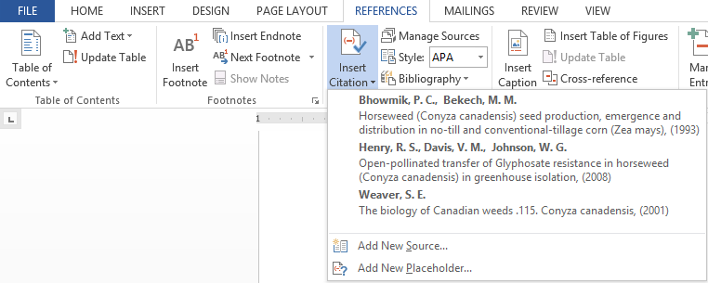

Figure 6. The existing sources

## Edit Inline Citations

After you add the reference, you can edit it. Move your cursor over the inline citation and click it, you will see a down arrow at the right of the inline citation. Click this arrow, a drop-down menu pops up.

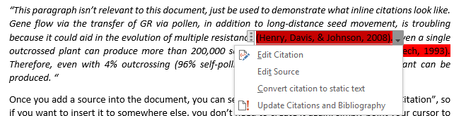

Figure 7. Edit the references

If you choose “Edit Citation”, the window in Figure 8 will pop up, you can choose what contents will be shown as inline citation, you can add page numbers to inline citation. The author and year are shown by default for APA 6th edition style, if you check the option box, the corresponding content will not be shown.

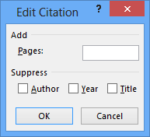

Figure 8. Edit inline citation

If you choose “Edit Source”, this action will bring you back to the window when you add this source. Then you can change whatever you want.

If you choose “Convert citation to static text”, you can change its contents as other texts in this document, but you cannot edit this source from here anymore. Sometimes, if the paper you cited has many authors, the inline citation will be very long. By default with “APA 6th edition” style, if the number of authors is more than 5, the inline citation will be shown as “Last name of the first author et al., year”. But if you want the inline citation to only show the first author when the number of authors is more than 3, then you can choose “convert citation to static text”, then edit it.

Another way to edit the source is to click on the “Manage Sources” menu in the Citations & Bibliography section of the References ribbon. See Figure 9. Select the source from the Master List or Current list, then click “Edit”, the window of editing source will pop up. And don’t forget to “Update Citations and Bibliography” after you edit the source.

Another convenience provided by MS Word reference manager is that all of the references you added in all word documents will be saved, and you can see them all from any word document. In Figure 9, there is a “Master List” which includes all of the references, if you want to insert a source in your current document, just select it in “Master List”, then click “Copy ->” button, it will be copied into the “Current List”, then you can insert it into your current document easily.

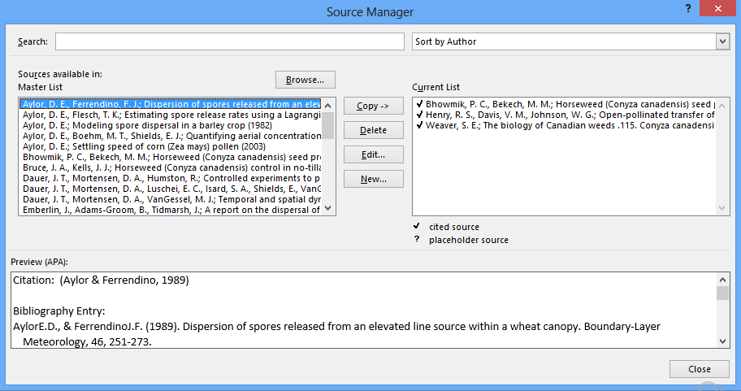

Figure 9. The source manager

# Add the References section

After you insert all the inline citations, adding the references section to your paper will be very easy, as simple as two mouse clicks. See Figure 10.

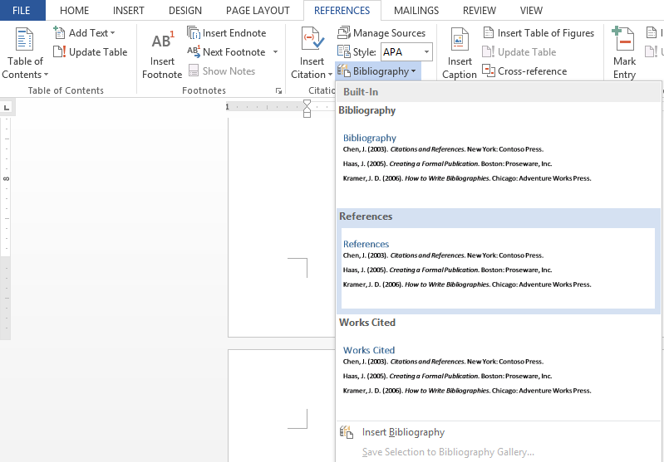

Figure 10. Insert the references section into the paper

In the Citations & Bibliography section of the References ribbon, click on the Bibliography drop-down menu. Depending on the requirements for your particular paper, choose either the bibliography, reference, or works cited type of bibliography to add it to the end of your paper. Each type will be perfectly referenced according to the style guide you chose in the style drop-down menu. See the References section of this document, which is not relevant to this document’s content, but it is automatically generated by MS Word reference manager.

If you add or change the references after you insert the reference section, you need to update the references section. Click on the “Update Citations and Bibliography” button at the top of the references page. The button will appear once you mouse over the reference section.

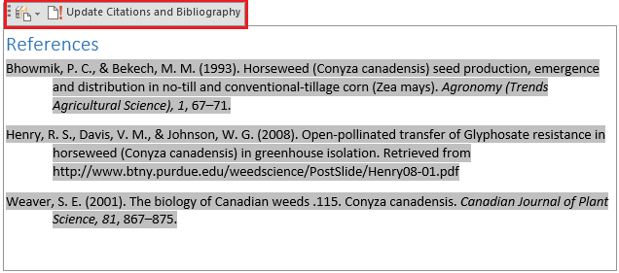

Figure 11. Update the reference

# Change the Style of References

You can change the style of the references even after you added all of them. See Figure 12.

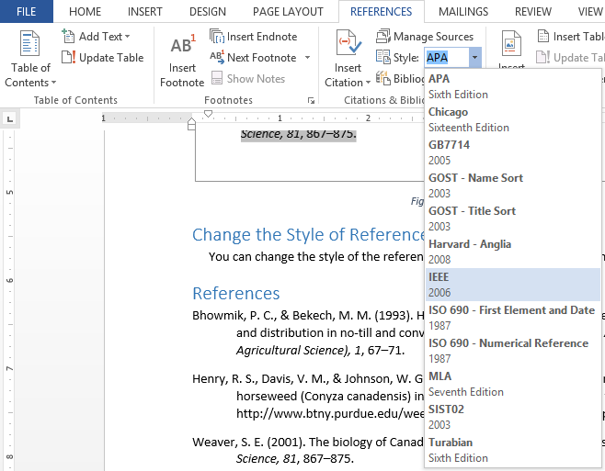

Figure 12. Change the style of references

For example, if you choose the style “IEEE 2006”, then all of inline citations and reference section will be automatically updated. The inline citations will look like Figure 13. And the reference section will be like Figure 14.

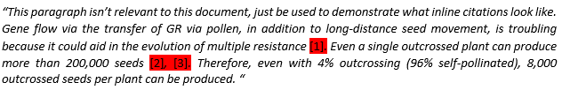

Figure 13. IEEE 2006 style inline citations

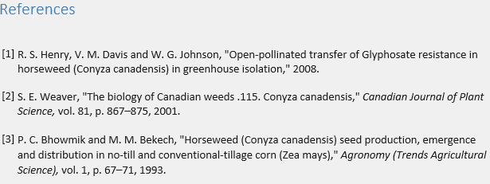

Figure 14. IEEE 2006 style references section

# References

Bhowmik, P. C., & Bekech, M. M. (1993). Horseweed (Conyza canadensis) seed production, emergence and distribution in no-till and conventional-tillage corn (Zea mays). *Agronomy (Trends Agricultural Science), 1*, 67–71.

Henry, R. S., Davis, V. M., & Johnson, W. G. (2008). Open-pollinated transfer of Glyphosate resistance in horseweed (Conyza canadensis) in greenhouse isolation. Retrieved from http://www.btny.purdue.edu/weedscience/PostSlide/Henry08-01.pdf

Weaver, S. E. (2001). The biology of Canadian weeds .115. Conyza canadensis. *Canadian Journal of Plant Science, 81*, 867–875.