Manual of creating KMZ files with Raymetrics scanning Lidar data

- Install SketchUp
SketchUp is a 3D modeling software. Here only version 8 from SketchUp has been tested and proofed for our script.
Install SketchUp and run the sketchupwen.exe program. Follow the instructions on screen. Please do not change the suggested default directory for installation. After finishing installation run for the first time the SketchUP.
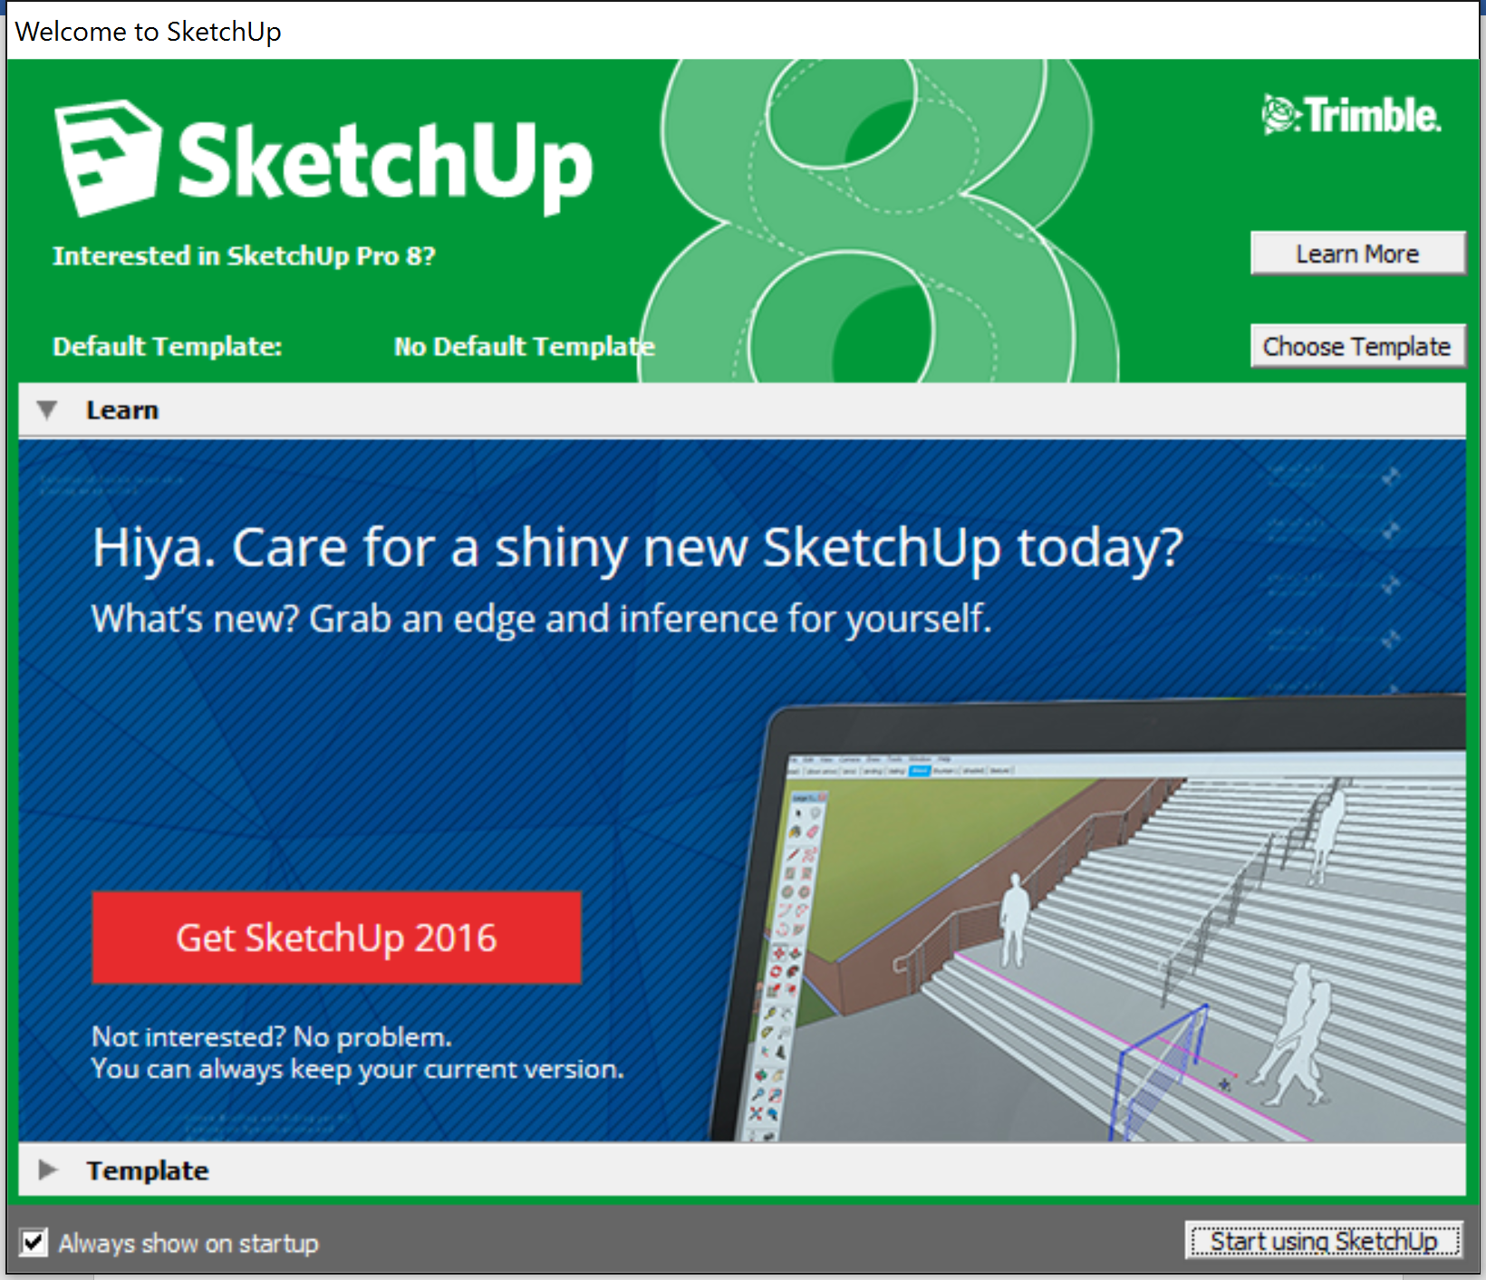
Uncheck the “Always show on startup. Then click the Choose Template.

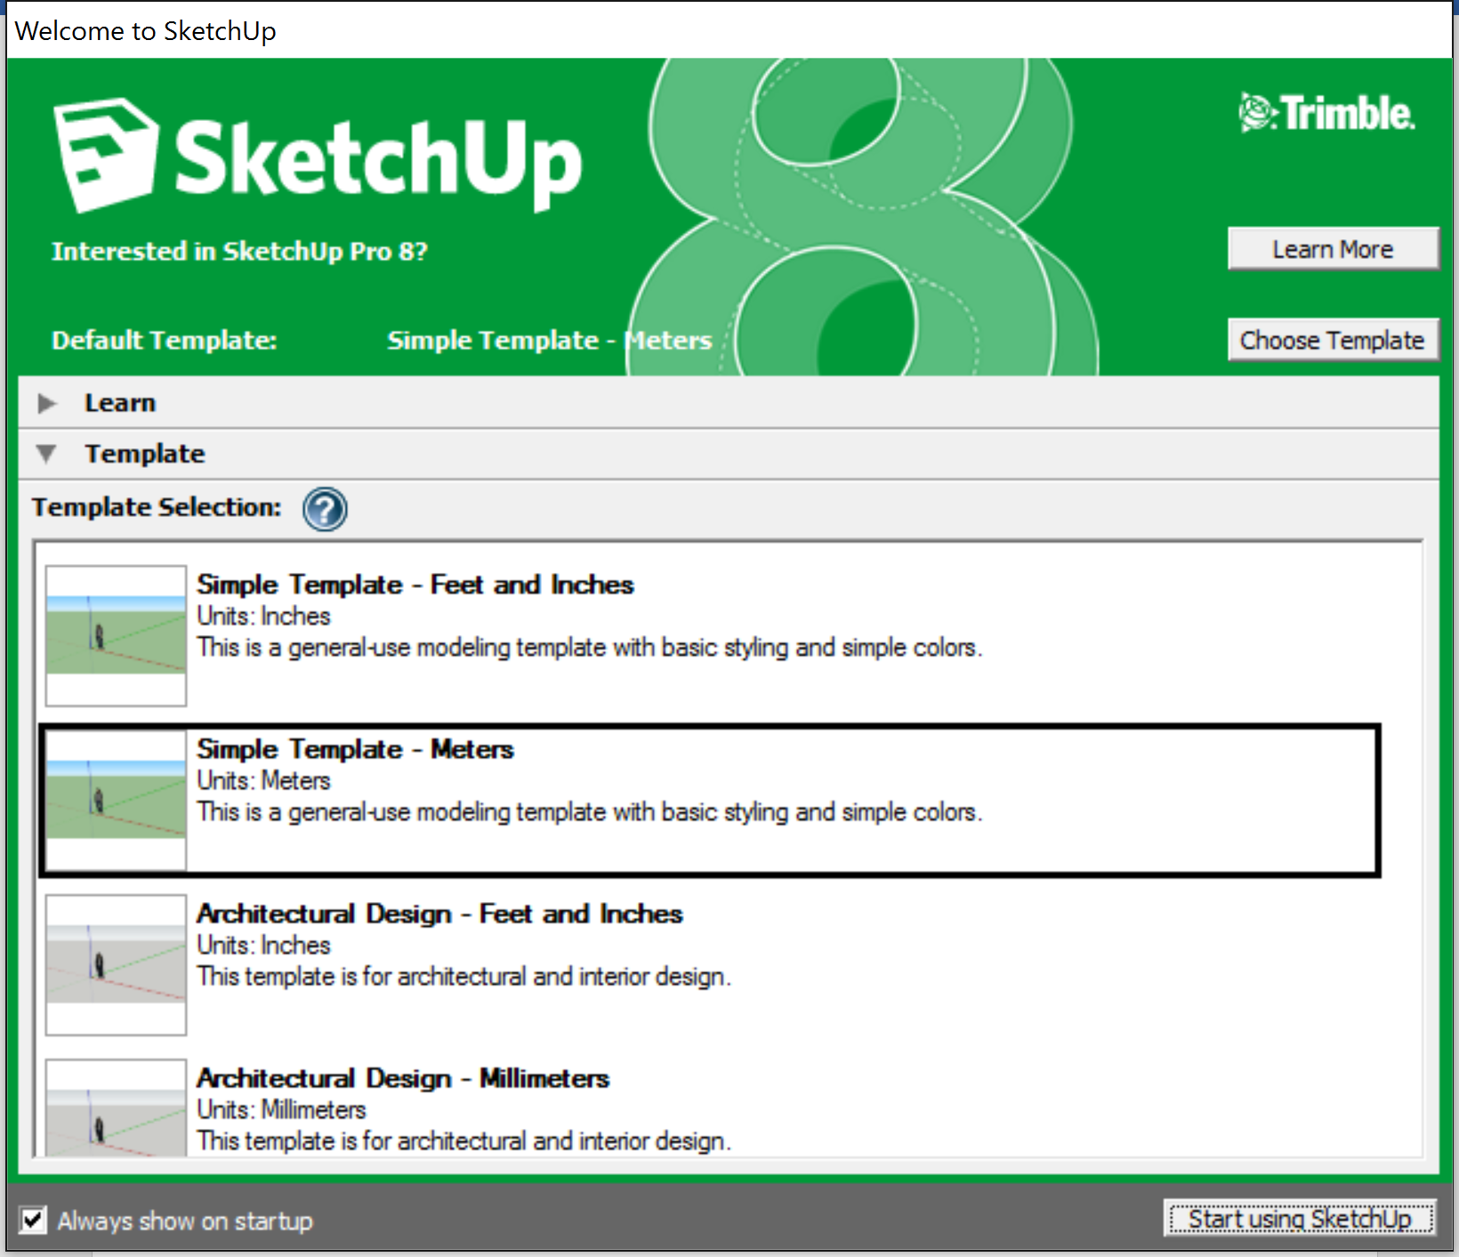

Select the “Simple Template – Meters” and click on “Start using SketchUp”.
Close the SketchUp.
- Add auto Script
Unzip SketchUp Auto Script.zip and copy all the content and paste them into the directory of C:\Program Files (x86)\Google\Google SketchUp 8\Plugins.
Run SketchUP and check “Plugins” as below:
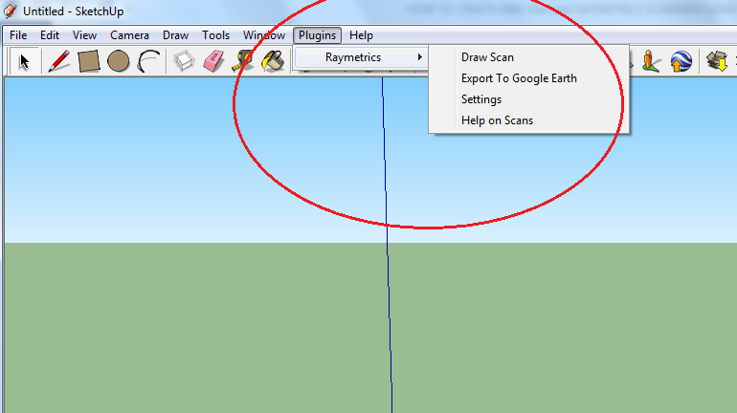
- Install Labview and Raymetrics Advanced Viewer
Install Labview 7.
Unzip RM_Advanced_Viewer.zip to any folder. Software does not need any installation if the Labview 7 or the runtime library for Labview 7 is installed to your computer.
Make sure that you have write permissions at the directory where you unzip and placed the RM_Advanced_Viewer.
Open the RM_Advanced_Viewer.ini file with any text editor and make sure that the Create KMZ parameter is set to TRUE.
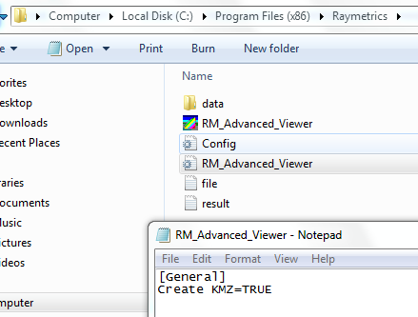
- Locate file.txt and result.txt files
Locate C:\Program Files (x86)\Google\Google SketchUp 8\Plugins directory.
Open the init.txt file and change the path of the file.txt and result.txt files. Put the path where the RM_Advanced_Viewer.exe is located.
Example as below:

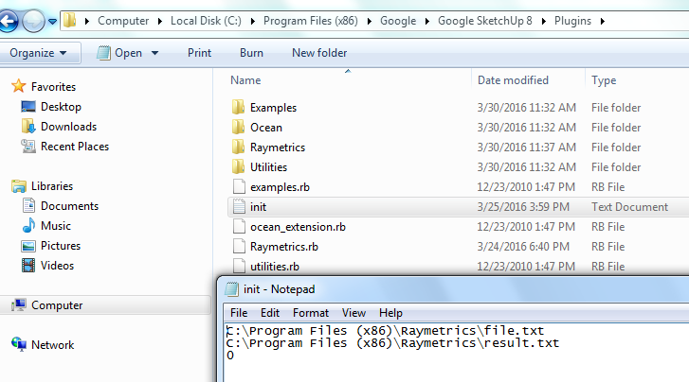

Now software is ready to create KMZ files ☺
- Create KMZ files
Run the RM_Advanced_Viewer.exe.
When the program starts, ask user to open a raw lidar datafile.
Locate a folder with a scanning measurements. After that click on the Plot Scan button.
Software asks the user to select the first raw data file of a single scan and the last one of a single scan measurement.
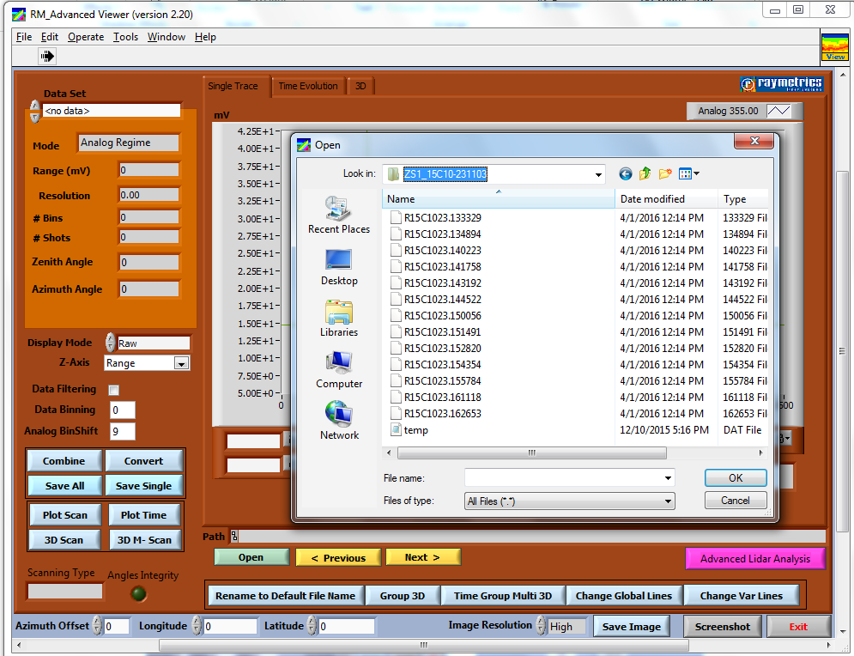
Select the dataset to work with and the final product that wants to plot.
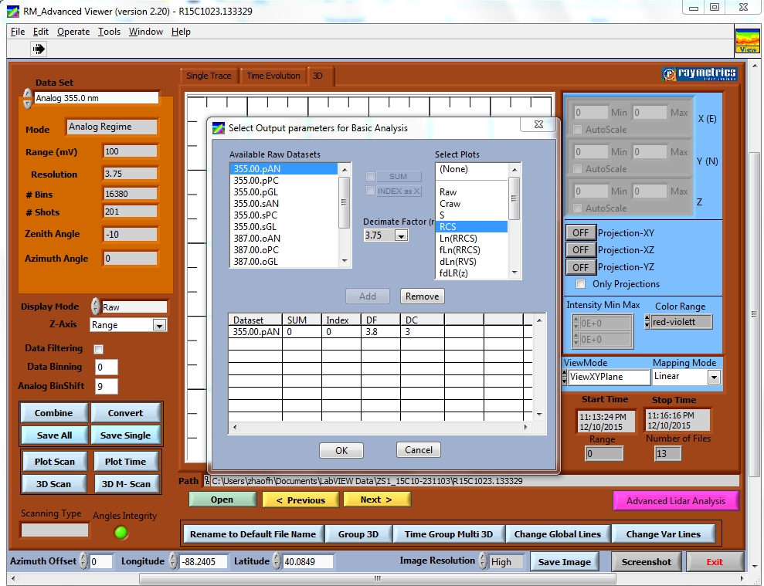
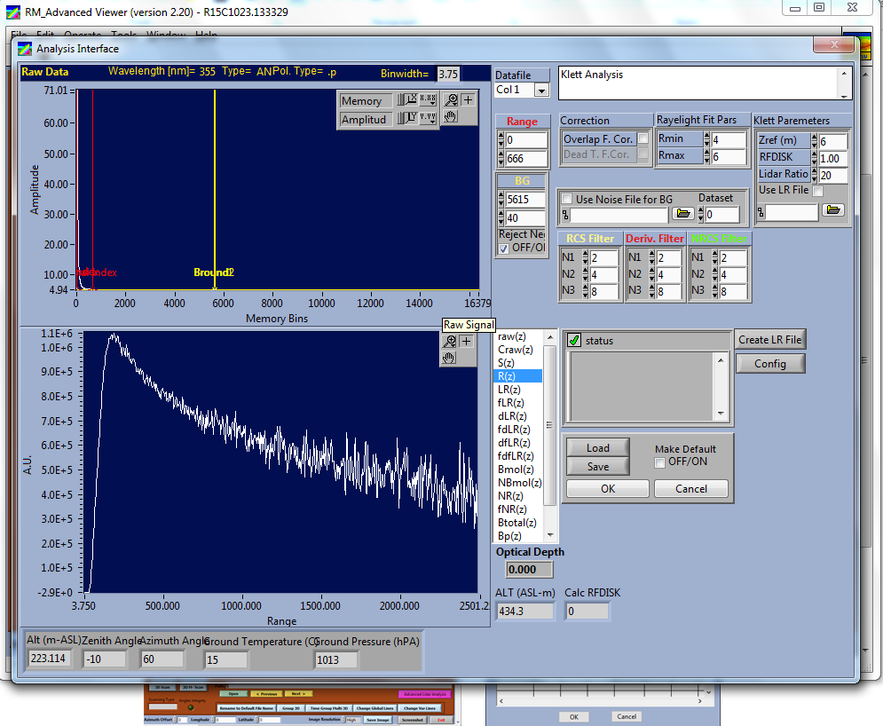
When user finish the analysis then software creates 3D graph.
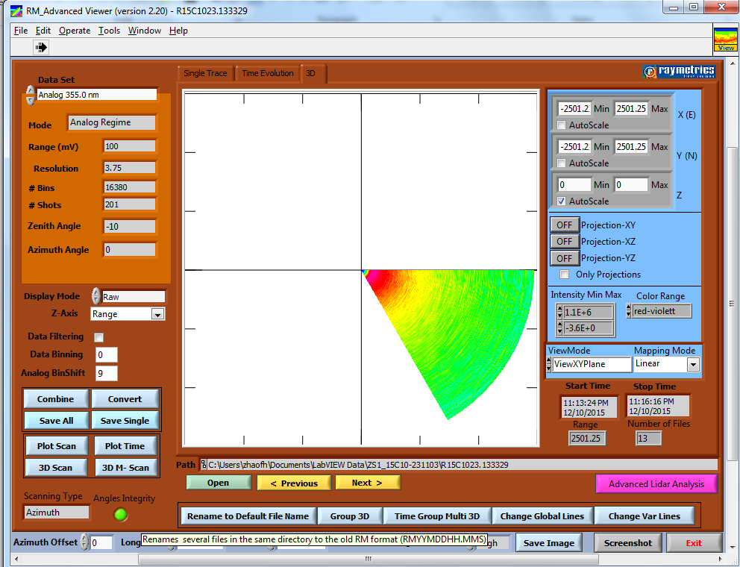
Click on the 3D tab and configure the 3D graph. Finally click the Save Image button. Select a folder to save the image and click at “Save Default” button. After a few seconds a KMZ file will also be created at the same directory.
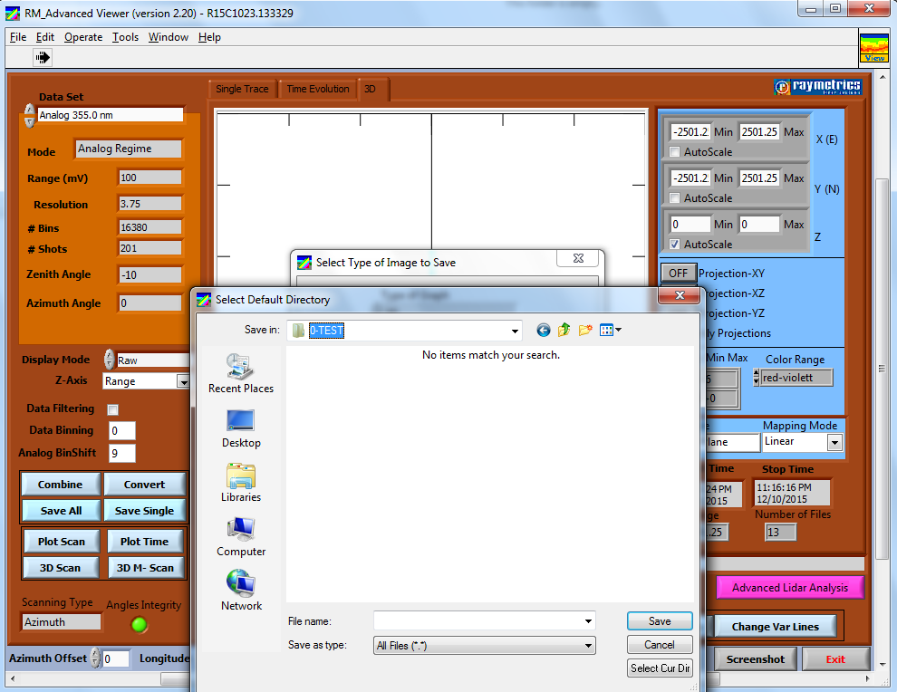
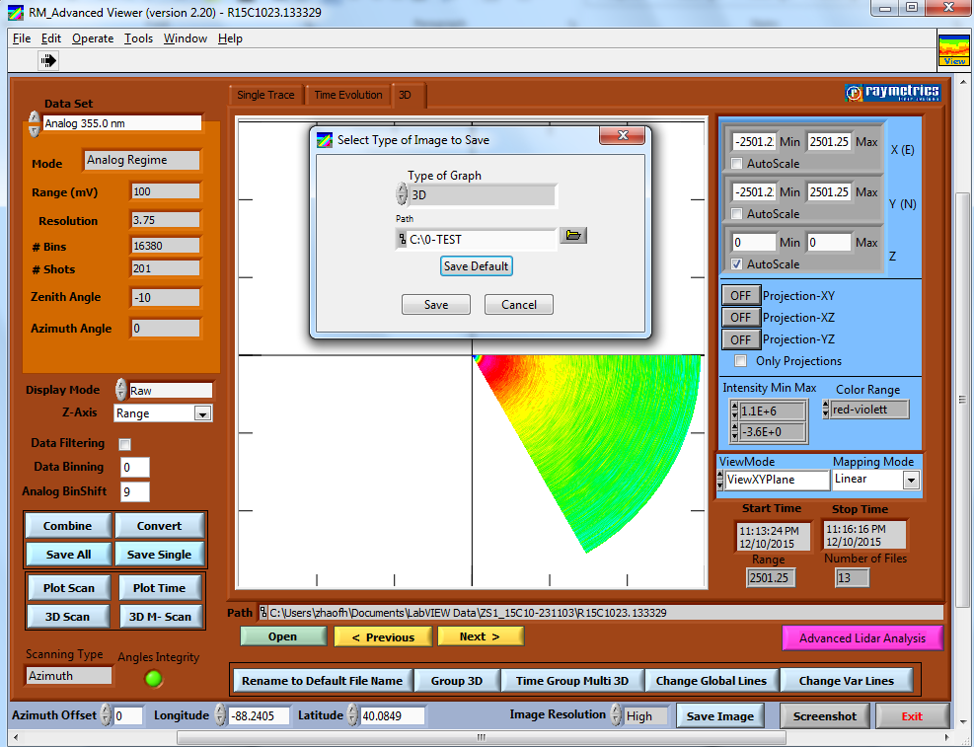
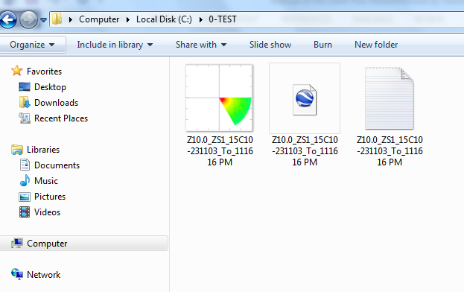

Show on Google earth.
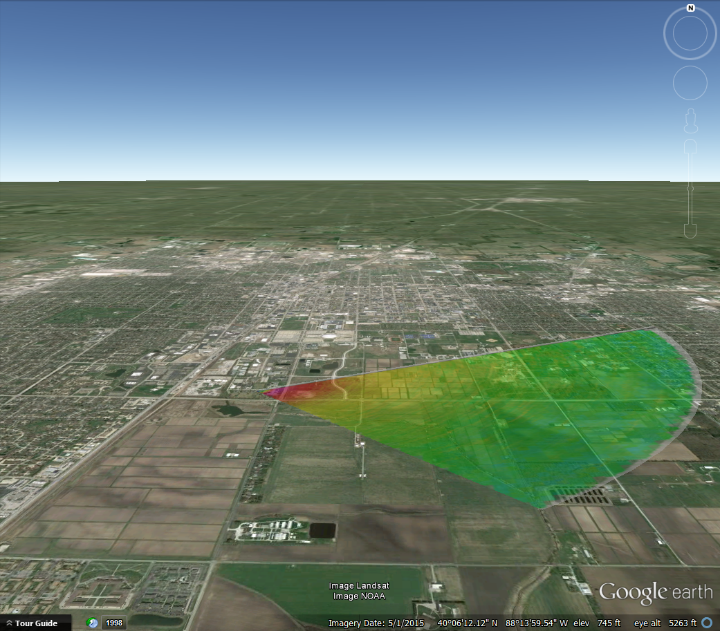

Other Info
- Make sure that your raw datafiles have correct info for longitude, latitude and Altitude.
- Make sure that your datafiles have correct info of the Azimuth offset parameter
If not, you could manually place this information at the button of the GUI of the program.
Note: Azimuth offset is the angle between East and the 0 degrees (Home position) of the Azimuth LIDAR head angle.
The Geometry
Y: N(A=270)
X: E(A=0)
-Y: S(A=90)
-X: W(A=180)

