Manual of the gene flow model program
1. How to run the program 1
2. Program structure 7
2.1 Function of FlyFromCircularSource 10
2.2 Function of Load3DData 12
2.3 The function of OpenGLRendering 14
3 How to adjust program parameters 20
3.1 Model precision 20
3.2 Settling speed 20
3.3 Source, buffer, receptor plant characteristics 20
3.4 Detection surface width and sphere radius 20
References 21
Project Source Codes Location: 21

1. How to run the program

The GeneFlow.exe is the program to predict the gene flow. When run the program,
first it shows a window.

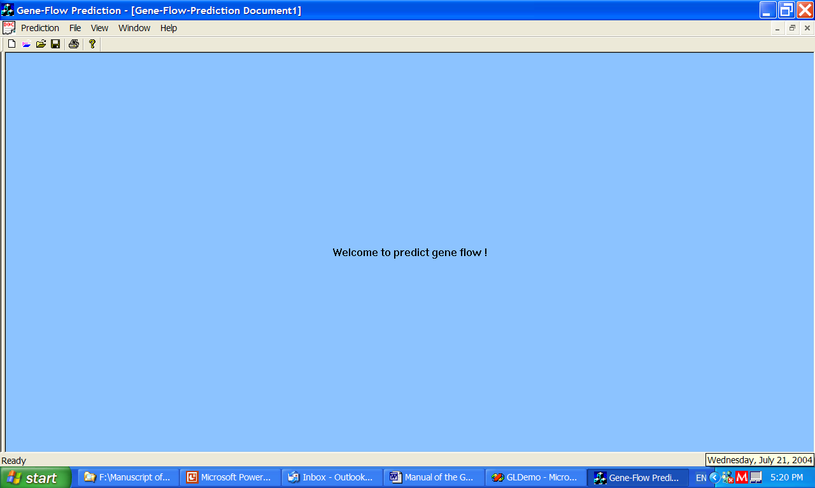

Click on the Prediction menu,
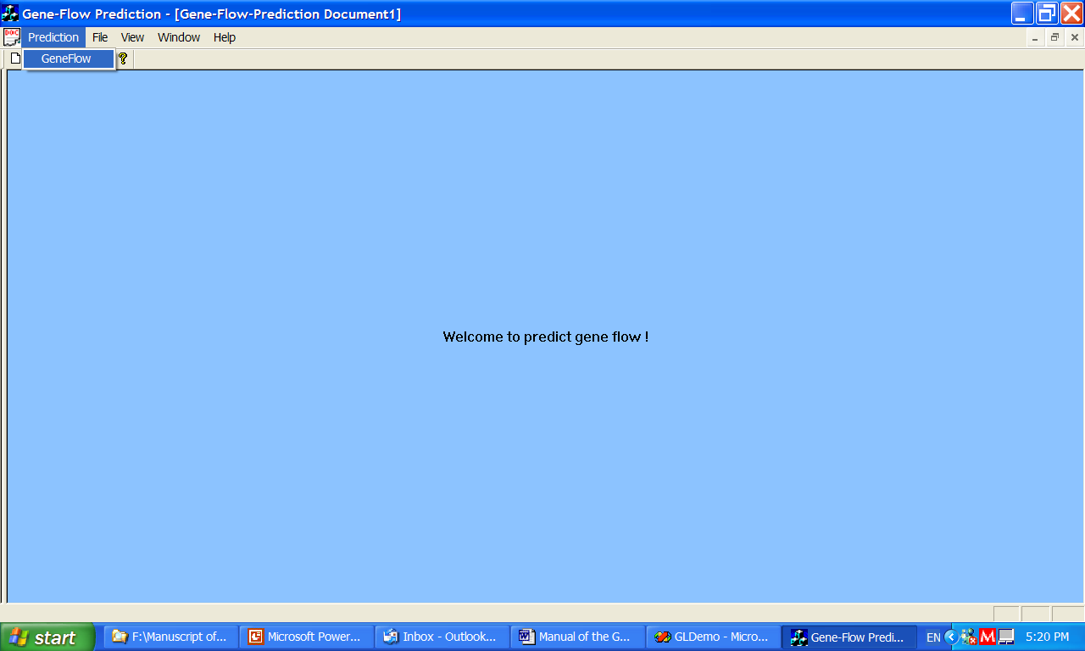
Click the Gene Flow button,

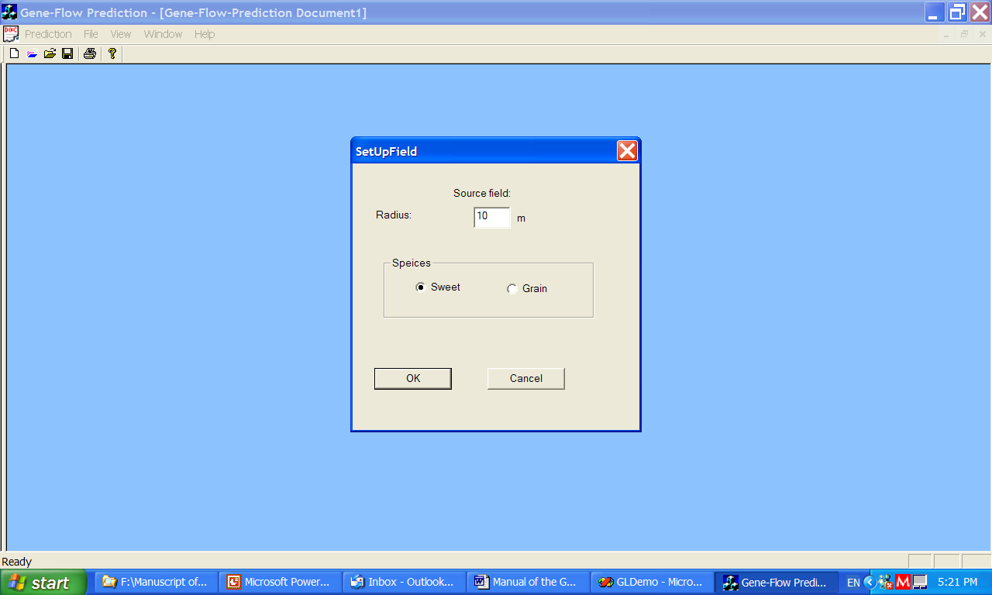

Choose the desired source species and fill out the radius. In the program the sweet corn was set height of 1.5 m and grain corn 2.83 m. The measured leaf area densities were used.

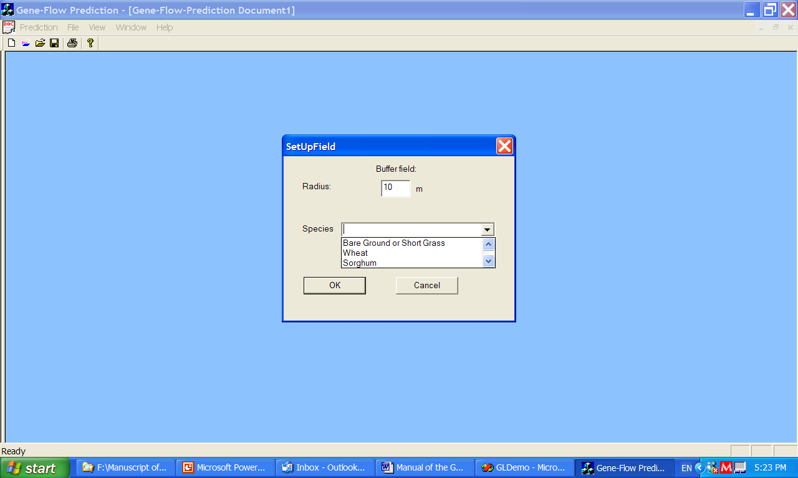
Choose the desired buffer species and fill out the radius. The radius is from the source center.
The bare ground is set to 0 LAI.
The wheat leaf characteristics were from Aylor and Ferrandino (1989) experiment in Flesh and Donald (2000). See the file of “Aylor1989WheatExperimentLAI.txt”. The format is:

1sr row: Total layer of canopy, each layer height (m).

2nd row:
LN LAD Fx Fz LD SAD Fx Fz SD
They represent layer number, leaf area density (m²/m³), Horizontal fractions of LAD, vertical fractions of LAD, leaf characteristic dimension (m), stem area density (m²/m³), Horizontal fractions of SAD, vertical fractions of SAD, stem characteristic dimension (m).

3rd – end rows:
Each row each item in order is layer number, leaf area density (m²/m³), Horizontal fractions of LAD, vertical fractions of LAD, leaf characteristic dimension (m), stem area density (m²/m³), Horizontal fractions of SAD, vertical fractions of SAD, stem characteristic dimension (m).

The sorghum leaf characteristics used 8419 W data. The 5 m plants were divided to 8 layers and each layer used the corresponding 8419 W leaf characteristic data. The data inputs are embedded in the program.

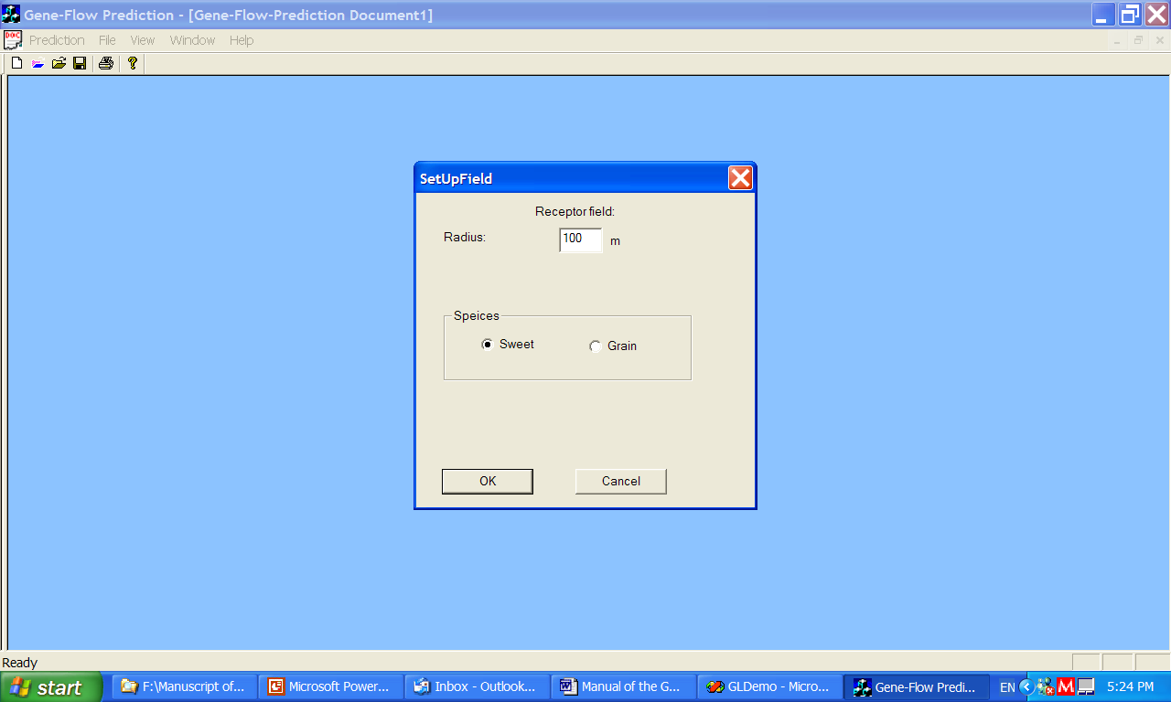
Choose the desired receptor species and fill out the radius. The radius is from the source center. The receptor plants include sweet and grain corn which used the measured plant characteristics of sweet and 8419W corn.

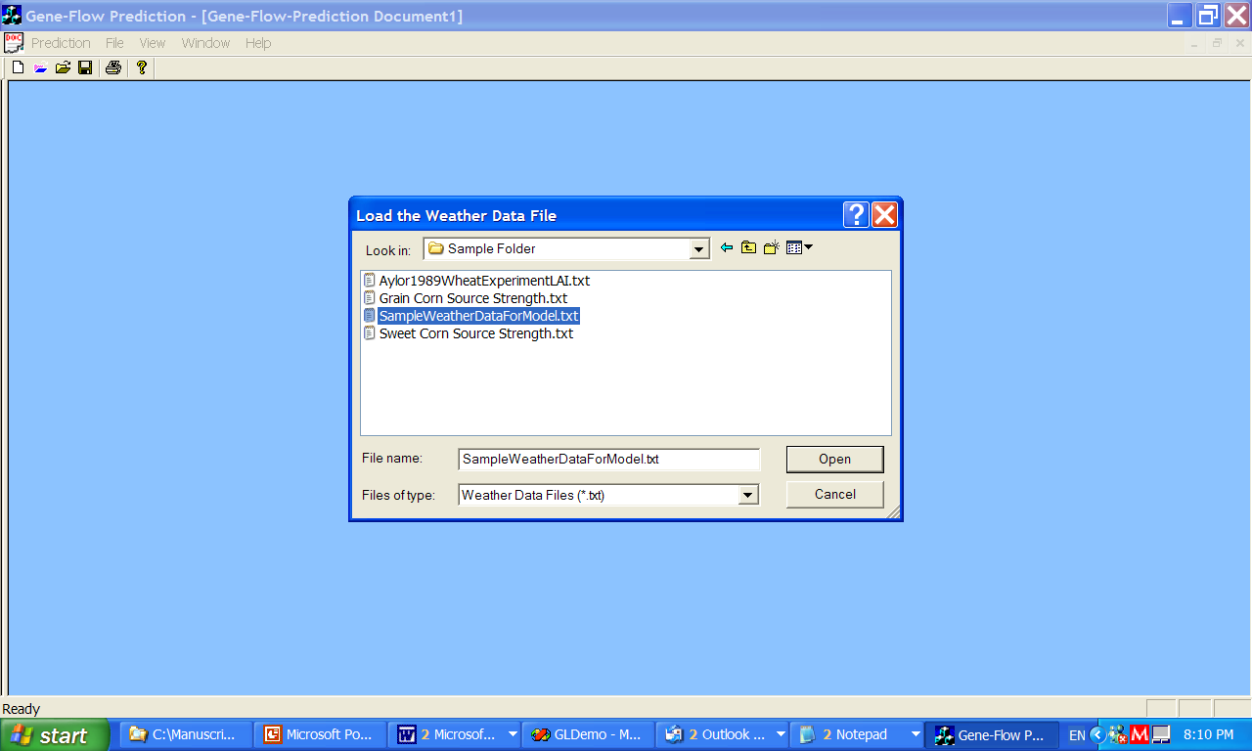

Then input the weather data file.
The weather data file should be in the file directory with the files of “Sweet Corn Source Strength.txt”, “Grain Corn Source Strength.txt”, and “Aylor1989WheatExperimentLAI.txt”. So the program can find the needed source strength and the wheat leaf characteristics.

The sample weather file is the “SampleWeatherDataForModel.txt”. The items in order in each row in the file are:
day, time, precipitation (mm), radiation (w/m²), air temperature (°C), wind speed (m/s), and wind direction (°).

The format for source strength is as the follows:
day, start time, end time, source strength (grains/m²/s)

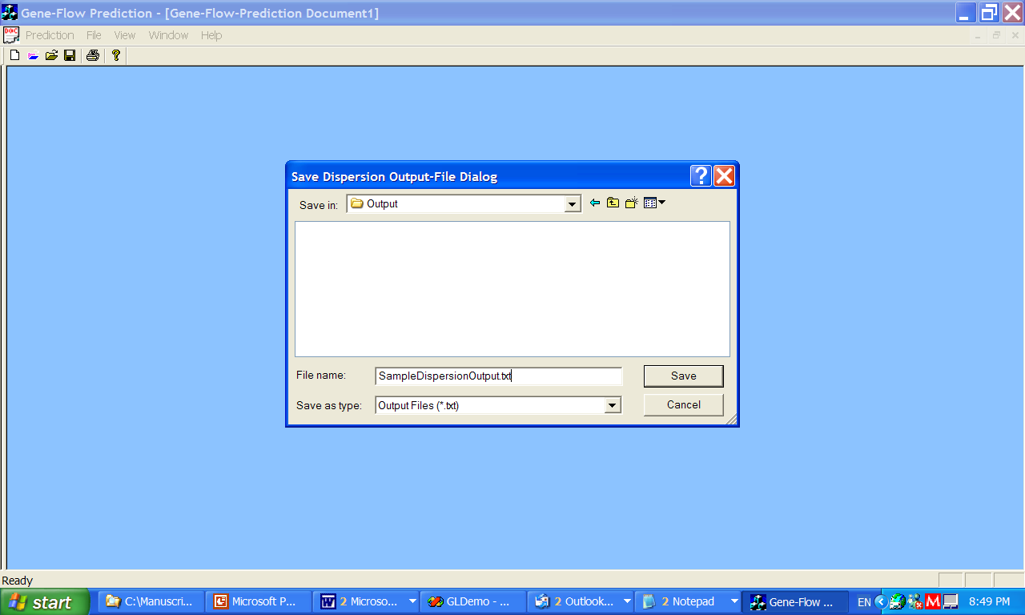

Then give the dispersion output file name. This file stores the outputs of dispersion and deposition.

See the “SampleDispersionOutput.txt”.

The format is as the follows:
During each 15-min,
1st row:
Day, time, u star (m/s), wind direction (°), Obukhov Length (m), source radius (m), source plant height (m), buffer radius (m), buffer plant height (m), receptor radius (m), receptor plant height (m).

2nd row on:
polar radius (m), angle from north direction (clockwise is positive, north is 0°), x-coordinate (0 at source center, south direction points to positive direction), y-coordinate, height, deposition flux density (grains/m²/s), accumulated deposition flux (grains/m²), concentration (grains/m³).

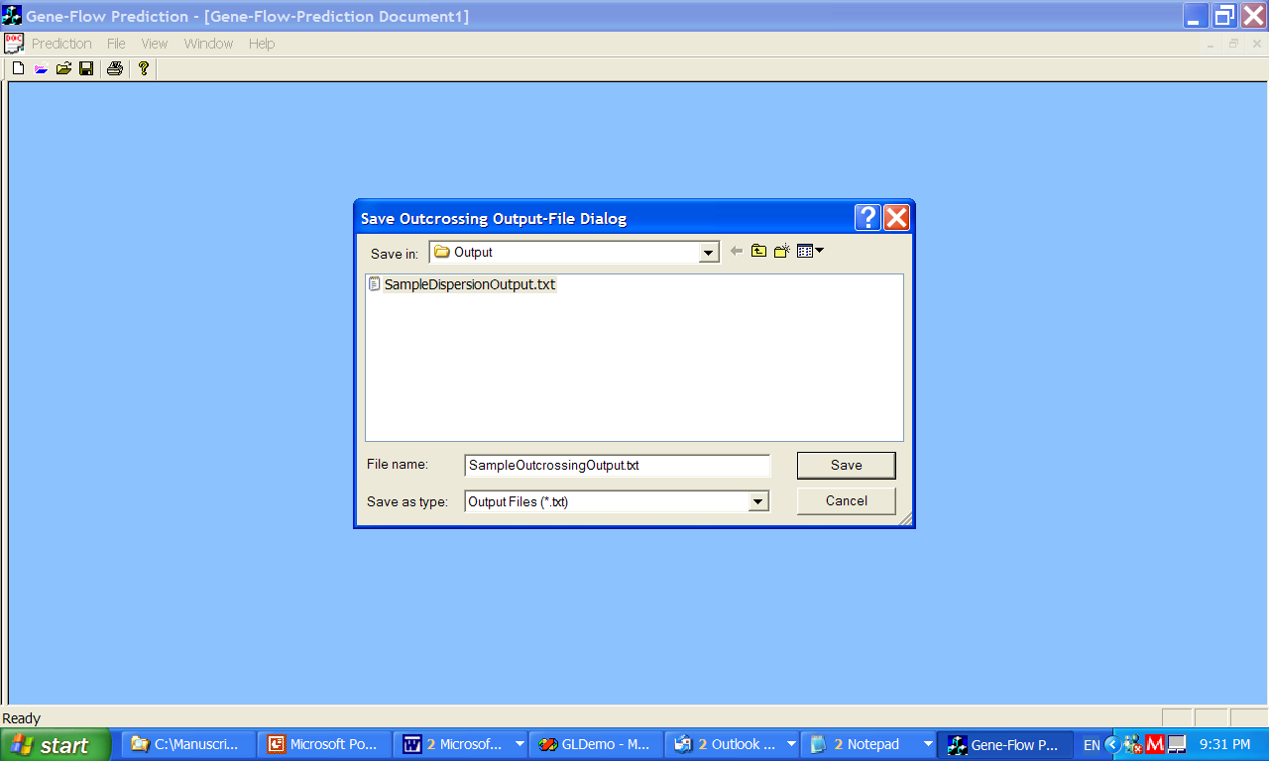
Then give the file name of outcrossing ratio output.

The formats for the file are as the follows:
polar radius (m), angle from north direction (clockwise is positive, north is 0°), x-coordinate (0 at source center, south direction points to positive direction), y-coordinate, outcrossing ratio.

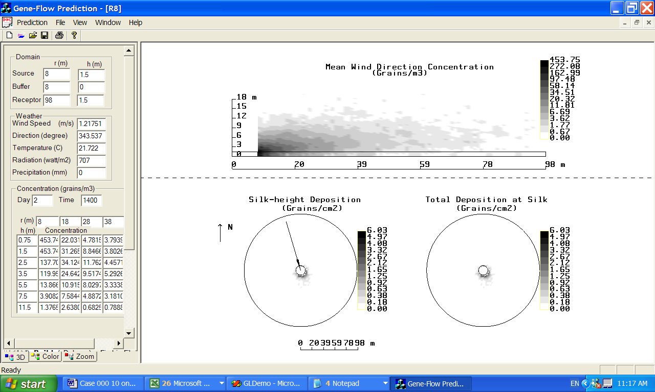

Then for every 15-min simulation, show the outputs once.

2. Program structure
The program used VC++ 6.0 environment. For graphs, the OpenGL classes were used. The following graph shows the general structure.

Figure 2.1. The general structure of the model.

The 3D random-walk simulation codes are in the file of “ChildFrm.cpp”.

The program starts from function of
void CChildFrame::OnPredictionAperiod()
The flowchart for the function is:
Figure 2.2. The flowchart for “void CChildFrame::OnPredictionAperiod()”
In above flowchart, “MyThreadProc” is a thread procedure which runs the function of “CalculationOfDispersion1()” which does the simulations.
The flowchart for “CalculationOfDispersion1()” is as the follows:
Figure 2.3. The flowchart for “CalculationOfDispersion1()”.

In above flowchart the function of “void FlyFromCircularSource(float SourceRadius, BOOL IfFinalResult)” in the file of “ChildFrm.cpp” does the simulations. SourceRadius is the radius of the source. IfFinalResult is a Boolean variable which is set to “TRUE” to save the simulation results.
The function of “void CGLDemoView::Load3DData( char type, DispersalArg Dispersal)” is in the file of “GLDemoView.cpp”. The function transfers and grids the data for graph show. The data is stored in “Dispersal”. The variable “type” is set to “C” for correct graph show type.
The OnDraw function draws the simulation graphs by functions of “OpenGLRendering()” and “Show3DForm(Dispersal1)”. Dispersal1 stores the shown data.

2.1 Function of FlyFromCircularSource
The following flowchart shows the function of “FlyFromCircularSource”.

Figure 2.4. The flowchart for “void FlyFromCircularSource(float SourceRadius, BOOL IfFinalResult)”.

The function of “OneCircularSourceGridFly(float SourceGridArea)” calculates the residence time and deposition accumulator. Where the SourceGridArea is the subsector area where the particles were released.
The flowchart for “OneCircularSourceGridFly” is as the follows:

Figure 2.5. The flowchart for “OneCircularSourceGridFly”
For calculating the concentration, the detection spheres were set.
In calculating the intersections of the line of a particle flight segment and the detection sphere. The following function was used:

sphere_line_intersection (
XBeforeOriCor, YBeforeOriCor , ZBefore,
xOriCor, yOriCor, z,
XCylinderCenter , YCylinderCenter, ZforIntersection,
HalfDetectorWidth )

Where XBeforeOriCor, YBeforeOriCor , ZBefore are coordinates of the start point before the flight; xOriCor, yOriCor, z are the coordinates of the end point after the flight; XCylinderCenter , YCylinderCenter, ZforIntersection are the coordinates of the center of the sphere. HalfDetectorWidth is the radius of th esphere. See the details in the function.

The following function judges if the flight start and end points are in the sphere so that the residence time can be calculated. The parameters were explained in the above function.

ifPointsIn(XBeforeOriCor , YBeforeOriCor , ZBefore, xOriCor , yOriCor , z ,
XCylinderCenter , YCylinderCenter , ZforIntersection, HalfDetectorWidth);

The following function calculates the distance between two points for future residence time calculation.
Distance(XBeforeOriCor,float YBeforeOriCor, ZBefore, x, y, z);

The following function judges if the two flight points are in the sphere.
JudgeIfsegmentIntersected(XBeforeOriCor , YBeforeOriCor , Zbefor, xOriCor , yOriCor , z , XCylinderCenter , YCylinderCenter , ZforIntersection, HalfDetectorWidth);

For the deposition calculation, the intersection of the flight line with the surface of detection height was first calculated. Then judge if the flight intersected with the closest surface.
The equilibrium wind calculations are in functions of “void SourceFieldEquilibriumWind()”, “void ReceptorFieldEquilibriumWind()”, and ”void OtherCanopyFieldEquilibriumWind()” in the file of “ChildFrm.cpp”.

2.2 Function of Load3DData
The function of “void CGLDemoView::Load3DData( char type, DispersalArg Dispersal)” is in the GLDemoView.cpp”. The function transfers and grids the data for graph show. Where the Dispersal is a structure which stores the simulation results. The “type” is a parameter which was set to “C” for showing the graph.

Then, this function calls the function ”void COpenGL3D::Load3DData( char type,DispersalArg& Dispersal)” in the file of “OpenGL3D.cpp”. Then the function of “Load3DMultipleMapsData( type, Dispersal)” was called which in fact does the gridding and data transferring. See the following flowchart.
Figure 2.6. The flowchart of the function of “Load3DmultipleMapsData”.

To grid the simulation data, Structure ScatData was used for defining the arrays storing the simulation data. The structure of SurfaceGrid was used to define the arrays which store the future gridded data. The function of “SetNext” sets the simulated data in arrays for future gridding. The function of “Xpand” does the gridding work. The structures and the two functions were adapted from W. John Coulthard. Details are in files of Xpand.cpp, surfacegrid.cpp, and scatdata.cpp.
“Init3DdataSet” function is in the file of “OpenGL3D.cpp”. The function initilize the parameters for the future graph show. The function of “Normalisation” in the file of “OpenGL3D.cpp” is for normalizing the data for future graph show. Finally, the m_pDS pointer points to the normalized arrays and the future graph show function will use the data the pointer points to.

2.3 The function of OpenGLRendering
The OnDraw function draws the simulation graphs by functions of “OpenGLRendering()” and “Show3DForm(Dispersal1)”.
The function “OpenGLRendering()” is in the “GLDemoView.cpp”. The function calls the “void COpenGL::OpenGLRendering()” in the file of “OpenGL.cpp”. The following flowchart shows the function structure.
Figure 2.7. The flowchart of “void COpenGL::OpenGLRendering()”.
In above flowchart, “OpenGLDrawbanner()”and “GDIGLDrawbanner()” draw the background graph which is in “OpenGL3D.cpp”. The two functions are in the file of “OpenGL3D.cpp”.
In above flowchart, the “OpenGLDrawMap()” draws the simulation graphs which is in “OpenGL3D.cpp”.
The following shows the flowchart for this function.

Figure 2.8. The flowchart of “OpenGLDrawMap()”.
In above flowchart, the function “DrawAxis()” in the file of “OpenGL.cpp” draws the scales, field circles, and wind direction for the graphs. The flowchart for the function is:

Figure 2.9. The flowchart of “DrawAxis()”.

In flowchart of Figure 2.8, the function of “DrawFlat()” defined in “OpenGL3D.cpp” draws the current deposition flux graph.
The flowchart for the function as the following.
Figure 2.10. The flowchart of “DrawFlat()”.
In flowchart of Figure 2.8, the function of “Draw2ndFlat()” and “DrawConcentrationFlat()” defined in “OpenGL3D.cpp” draw the accumulated deposition flux and concentration graphs. The function structures are similar to the function of “DrawFlat()”.
In flowchart of Figure 2.8, the function of “DrawLegend()” defined in “OpenGL.cpp” draws the legends for the graphs. The flowchart is as the following.
Figure 2.11. The flowchart of “DrawLegend()”.
In above flowchart the function “Legend(rt)” defined in “OpenGL3D.cpp” draws the values of the legend. The following shows the flowchart for this function.

Figure 2.12. The flowchart of “Legend”.

3 How to adjust program parameters

3.1 Model precision
The released particle number (Np) and the source subsector number ” in the file of “ChildFrm.cpp” control the procision of the output. Subsectror number is divided radially by “SegmentNo” and angularly by “AngleDivision” in the codes. For better precision, choose bigger Np, SegmentNo, and AngleDivision. But the running time will be longer. In this program, Np is set to 200 for source radius<=50 m, 80 for bigger radius.
The AngleDivision and SegmentNo were set in terms of source radius, i.e.

AngleDivision=72*(SourceRadius/8);
SegmentNo=60*(SourceRadius/8);

3.2 Settling speed
The pollen settling speed can be adjusted by the sentence of “SettlingSpeed=” in the file of “ChildFrm.cpp”. In the codes, “SettlingSpeed” is set to 0.31.

3.3 Source, buffer, receptor plant characteristics
The heights of source and receptor plants are set to 1.5 m for sweet corn and 2.83 m for grain corn in function of “void SetUpCanopy()” in the file of “ChildFrm.cpp”. The heights can be adjusted by sentences of “ReceptorFieldHeight=” or “SourceFieldHeight=”.
The density of the plants are set also in the function. The density for sweet corn is set to 53386 plants/ha and for grain corn 71187 plants/ha. It can be adjusted by sentence of “SourceFieldDensity=”.
Wheat buffer plant characteristics were set to data in the file of “Aylor1989WheatExperimentLAI.txt”. The format details are in the fourth step “input buffer” in section 1 “How to run the program”. Other plant characteristics please refer to the fourth step also. To adjust the characteristics, please go to the part of “PlantTypeIndex==” in file of “ChildFrm.cpp”.

3.4 Detection surface width and sphere radius
The Detection surface width and detection sphere radius is set by “HalfDetectorWidth=”. It can be adjusted. This parameter was set to 0.16 m.

References
Aylor, D. E. and F. J. Ferrendino. 1989. Dispersion of spores released from an elevated line source within a wheat canopy. Boundary-Layer Meteorol. 46: 251-273.

Flesh, T. K., and D. E. Aylor. 2000, A Lagrangian Stochastic dispersion model for assessing pesticide spray drift in an Orchard Canopy. Technical report to the U.S. Environmental Protection Agency on grant # 823627-01-1 to New Mexico State University subgrant Q00153 to the University of Connecticut.

Project Source Codes Location:
C:\phpapp\Geneflow\GeneFlow VC++ Program - 2013

