**Model Validation**

**Contents**

**Introduction:** 2

**Field Data File:** 2

**Steps for validation:** 3

**MATLAB Program:** 4

**Model_testing.m** 4

**plot_sim_data.m** 5

**measured_nwatch_data.m** 5

# **Introduction:**

The Ntrack model was previously calibrated using the ISWS WARM weather data while the online tool is using NWS weather data. The purpose of this document is to validate online N-tracking model’s predictive accuracy against the field observations with NWS weather data.

# **Online tool deployment**

The online tool has been deployed on the server next to Junming’s office.

**Server name**: SWSATMOSCI

**Server IP**: 130.126.104.12

**Web pages fold**: C:\Program Files (x86)\NMSU\RSET\wwwroot\ntrack

**Source code location**: C:\Program Files (x86)\NMSU\RSET\wwwroot\ntrack\ ntracker.rar

Ps: there are two servers, and one is \\ SWSRSETSERVER (Ip:130.126.104.33), and another is \\SWSATMOSCI(Ip: 130.126.104.12). The web pages for the online tools were deployed on the SWSATMOSCI server.

## **Model Input**

# *Weather Data File:*

**Weather Data file description**: The online tool is using NWS weather data.

**NWS daily weather data location**: E:/2017Data/NWS/

# *Soil Data File:*

**Soil data file description**: Soil file is processed from gSSURGO.

**Soil data file location**: \\SWSRSETSERVER, E:/SunY/Soildata/IL_Soil_Data_Base_Das.txt.

# *Field Data File:*

1. Main field data file

**Field data name**: ‘All REC N Tracking Results 2016.xlsx’.

**Field data location**: \Validation_niu.

**Field data file description**: The file contains field observation data such that each excel sheet corresponds to all the N treatment results from one site. Each site has different plots that were treated with different amount of N at different times of the year, e.g. Fall or Spring. Different treatments are coded with numerical numbers. Table 1 provides all the sites, their abbreviation and their location. Table 2 provides all the treatment codes and their explanation.

**Table 1**: Treatment numbers and corresponding N application practices.

|  |  |  |  |
| --- | --- | --- | --- |
| sites # | Full Name | Abbreviation(four letters) | Latitude, longitude |
| 1 | DeKalb | dekl | 41.8435 -88.857 |
| 2 | Monmouth | monm | 40.9366 -90.7212 |
| 3 | Urbana | uiub | 40.046 -88.2287 |
| 4 | Perry-Orr | pery | 39.7913 -90.8239 |
| 5 | Neoga | neog | 39.2498 -88.4072 |
| 6 | Marion | We will not be using the yield data from this site due to stand and uniformity problems. |  |

**Table 2**: Treatment numbers and corresponding N application practices.

|  |  |  |
| --- | --- | --- |
| Treatment # | N Application | Note |
| 1 | 200 Fall + NS (N-Serve) |  |
| 2 | 200 Fall no NS |  |
| 3 | 100 Fa/NS+50P+50SD |  |
| 4 | 200 Spring no NS |  |
| 5 | 200 Spring + NS |  |
| 6 | 50P + 150 SD |  |
| 7 | no N |  |

In the ‘Sites and dates’ sheet of the ‘All REC N Tracking Results 2016.xlsx’, there are the planting date , N application dates and soil sampling dates. The planting date, N application dates, and N amount for specific site needs to input the N track online tool.

## **Model Output**

**File Name**:Shown in Figure 1.

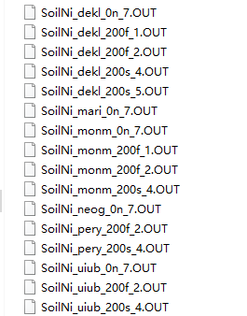

Figure 1. The output files of dssat46 model

The model output file is like Figure 2.T

The output file of dssat46 model which is called by the online N track tool has the extension file name *.OUT.

**File location:** \\SWSATMOSCI(Ip: 130.126.104.12),C:\DSSAT46\Maize

**File Description**: The content of the out file is shown in Figure 2.

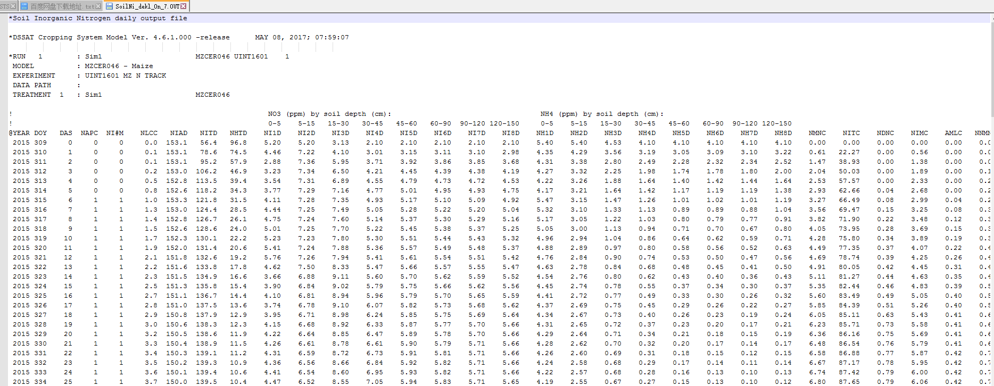

Figure 2. The content of the out file.

The descriptions for used columns are in the Table 3.

**Table 3**: Treatment numbers and corresponding N application practices.

|  |  |  |
| --- | --- | --- |
| Column number | Column name | descrition |
| 1 | @YEAR | The year of the simulation |
| 2 | DOY | The day of the year |
| 10 | NI1D | For the calculation of NO3_1 |
| 11 | NI2D |
| 12 | NI3D |
| 13 | NI4D | For the calculation of NO3_2 |
| 14 | NI5D |
| 18 | NH1D | For the calculation of NH4_1 |
| 19 | NH2D |
| 20 | NH3D |
| 21 | NH4D | For the calculation of NH4_2 |
| 22 | NH5D |

The formulations for the calculation of NO3 and NH4 are shown as follows.

$NO3_{1}=\frac{NI1D*5+NI12D*10+NI3D*15}{30}$ (1)

$NO3_{2}=\frac{NI4D*15+NI5D*15}{30}$ (2)

$NH4_{1}=\frac{NH1D*5+NH2D*10+NH3D*15}{30}$ (3)

$NH4_{2}=\frac{NH4D*15+NH5D*15}{30}$ (4)

## **Measured Field Data**

**File location:** \Validation_niu.

**File name**: shown in Figure 3.

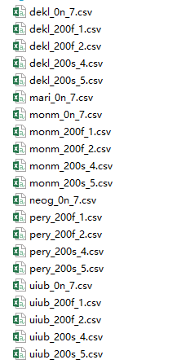

Figure 3. The measured field data.

**File description**: The measured field data is also contained in the main field source file—‘All REC N Tracking Results 2016.xlsx’. For ease of use, the data for each site and each type has been copied to individual files because main file’s format has a certain randomness in how the data was recorded and is not readily available to be used in any program. The new files are also available in the same folder as that of the main field data file and the files are named as xxxx_Ntype_trt#.csv. Here xxxx is a four letter code for the site, which can be found in table1, and Ntype is the N application type, e.g. 200f for 200 lbs/acre N applied in Fall or 200s for 200 lbs/acre N applied in Spring, and trt# is the treatment code as found in table 2.

Each file contains the date of the observation, treatment code, and **NO3 and NH4 concentrations in first (0-1 ft) and second depths (1 – 2 ft) (table 4)**. **This data is used to compare with the data obtained by DSSAT simulations at the same site with same N treatment to test model’s predictive accuracies.**

**Table 4**: Structure of the table for each site and each treatment

|  |  |  |  |  |  |
| --- | --- | --- | --- | --- | --- |
| Date | Trt | NO3_1 | NO3_2 | NH4_1 | NH4_2 |
| 11/12/2015 | 7 | 5.4 | 3.5 | 1.8 | 3.3 |
| 04/14/2016 | 7 | 3.6 | 3.2 | 5.7 | 3.3 |
| 05/07/2016 | 7 | 5.3 | 5.4 | 2.9 | 2.7 |
| 05/20/2016 | 7 | 6.8 | 4.9 | 5.2 | 2 |
| 06/03/2016 | 7 | 10.8 | 7 | 5.9 | 1.8 |
| 06/17/2016 | 7 | 7.7 | 4.8 | 4.8 | 3.1 |

# **Steps for validation:**

The process of model validation involves few manual steps before running the MATLAB program. These steps include the following:

1. Submit a simulation request to the online tool. The user will have to submit a separate request for each site and for each N application type. The input to the online tools should be according to the data provided in the main excel file, especially the sheet—“Sites and dates”.
   1. Note down the observation period from the observed data. Simulation should start just before the first date of observation and should end at the harvest stage or after the last date of observation. For example, for the case of table 4, the simulation start date can be 3-5 days before 11/12/15 and the end date can be 3-5 days after 06/17/16. This is important to be able to compare all observed date’s data with the simulation data.
   2. Enter the location (Latitude/Longitude) of each field site according to the Table 1.
   3. Submit a request to process the data.
2. Go to the DSSAT’s directory (C:\DSSAT46\Maize) and rename the file SoilNi.Out to SoilNi_xxxx_Ntype_trt#.Out. For example, for Urbana (uiub) with 200 lbs/acre in fall (200f) and treatment number 2 (no NS), the name would be SoilNi_uiub_200f_2.OUT.
3. Repeat step 1-2 for each site and for each N application, every time changing the name of output file (SoilNi.Out) according to the above described naming convention.
4. The MATLAB program is set to run for all six sites (Table1) with same N application type together. To run the program and compare simulated versus observed data at all the six sites, change the variable name ‘filenames’ on line 3 of ’Validation2016.m’ to whatever N application is desired to run. The filenames have been assigned like figure 4.

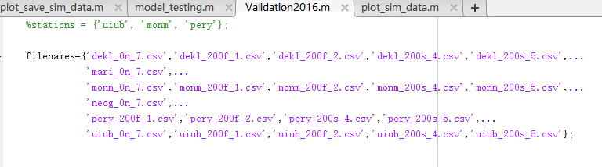

Figure 4. The current individual soil field files

If other individual soil field files need to be processed for simulation, you should change the value of the filenames .

**Note**: If the program fails, it is most probably due to non-existence of the corresponding SoilNi_*.OUT file. Repeat steps 1-2 for the missing file and run the program again

# **MATLAB Program:**

The MATLAB program that automates the process of reading simulation outputs and plotting the simulated versus observed data for comparison is located on \\SWSATMOSSCI in the directory C:\Users\Administrator\Documents\MATLAB\app_test. The program has the following files and structure:

Model_testing.m

plot_sim_data.m

measured_nwatch_data.m

## **Model_testing.m**

This is the main module where user can change the variable ‘filename’ to run the simulations for the three stations.

## **plot_sim_data.m**

This function takes in the provided DSSAT output file (SoilNi_*.OUT), corresponding field data csv file, and output file name for the output plot, and produces comparison plots for the three stations.

## **measured_nwatch_data.m**

This function takes in csv data and calculates total NO3 and NH4 at the two depths.

**N-Track Online Tool Documentation**

Table of Contents

**1** **Summary** 2

**2** **General Flowchart of the program** 2

**3** **Web Interface Flow Chart** 3

**4** **Flow Chart for Server Side Process** 4

**5** **Description of Files** 5

**5.1** **Index.php** 5

**5.2** **Mysql.php** 5

**5.2.1** **Database fields** 6

**5.3** **Register.php** 7

**5.4** **main.php** 7

**5.5** **daemon.php** 8

**5.5.1** **Source Code Location** 8

**5.5.2** **The Program (ntracker_run.m) Structure** 9

**5.5.2.1** **Summary** 9

**5.5.2.2** **Description** 9

**5.5.2.2.1** **ntracker_run.m:** 9

**5.5.2.2.2** **import_userdata.m:** 9

**5.5.2.2.3** **soil.m:** 10

**5.5.2.2.4** **weather.m:** 10

**5.5.2.2.5** **process_filex.m:** 11

# **Summary**

The N-tracking tool is an online tool for simulating soil nitrogen dynamics for a user-defined location in cornfields within Illinois. DSSAT software, version 4.6, is used for N concentration calculations based on the soil and meteorological data stored on the server. The DSSAT program is run for user specified duration and location, and the average nitrogen concentration within 0-1 and 1-2 feet is calculated. The graphical output web linksare sent to the users’ email address.

The overall implementation of the tool can be described as follows:

* + User submits the nitrogen tracking calculation request through the online tool website.
  + Each request is stored in a queue, and the online tool is ready to receive other requests. All the requests are also stored in another requests log table.
  + The queued requests are processed on a First-In-First-Out (FIFO) basis.
  + After the successful processing, the request is deleted from the queue, and an email is sent to the requester with the input parameters and the corresponding nitrogen profile link.
  + After sending the email, another request in the queue is processed. This process repeats until the queue is empty.

# **General Flowchart of the program**

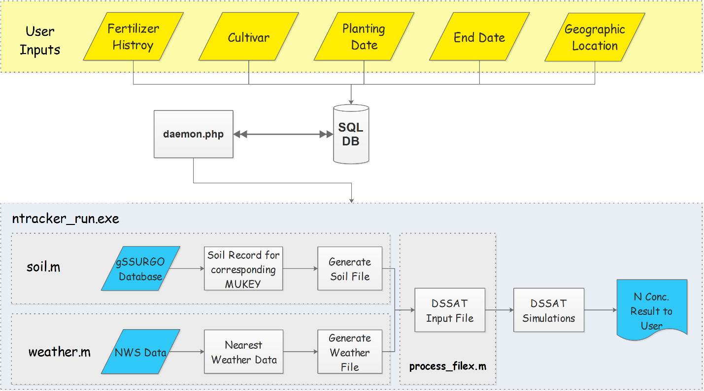

The online tool can be divided into two major functional components:

* Web interface
* Background process

The following flowcharts explain the functional flow of the components.

# **Web Interface Flow Chart**

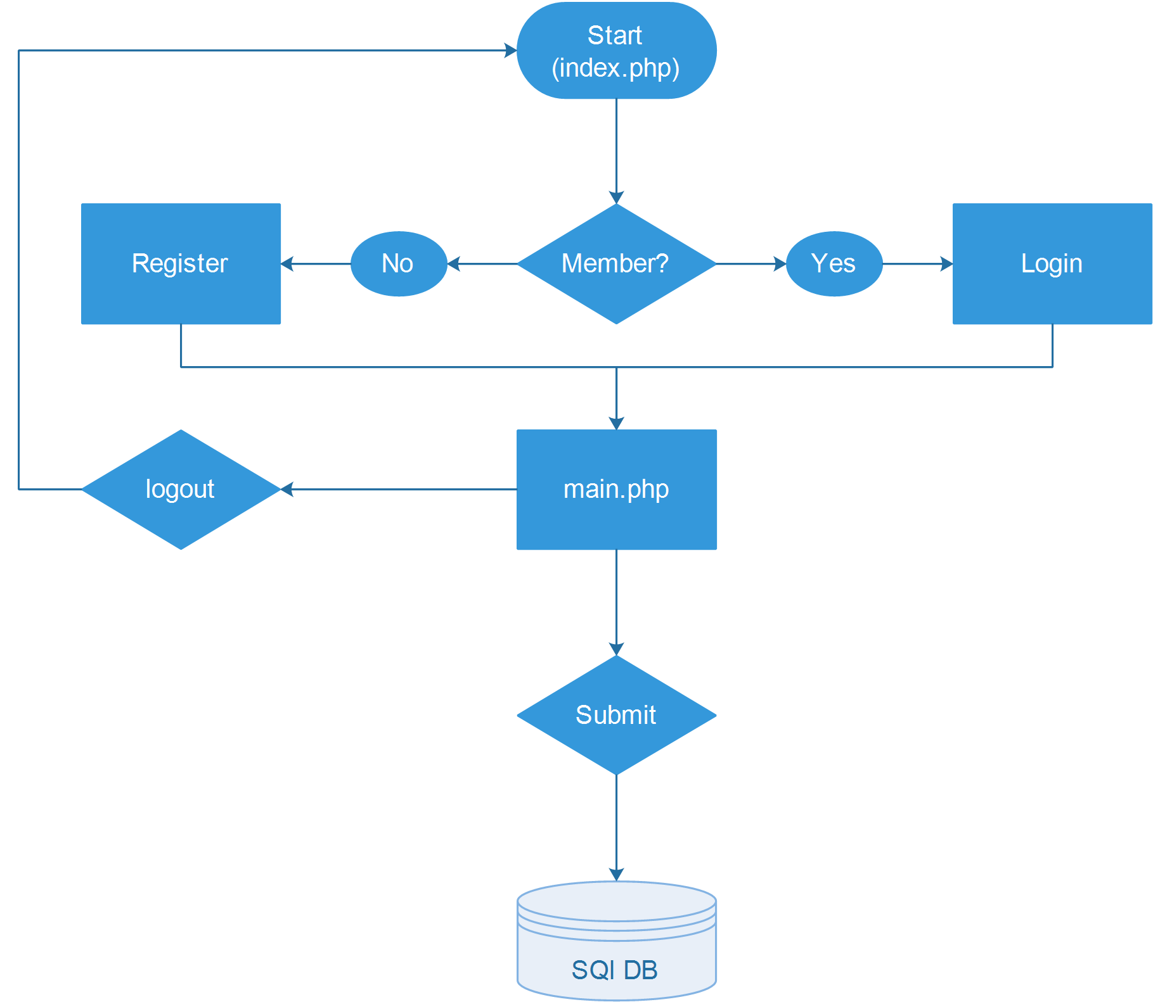

# **Flow Chart for Server Side Process (daemon.php)**

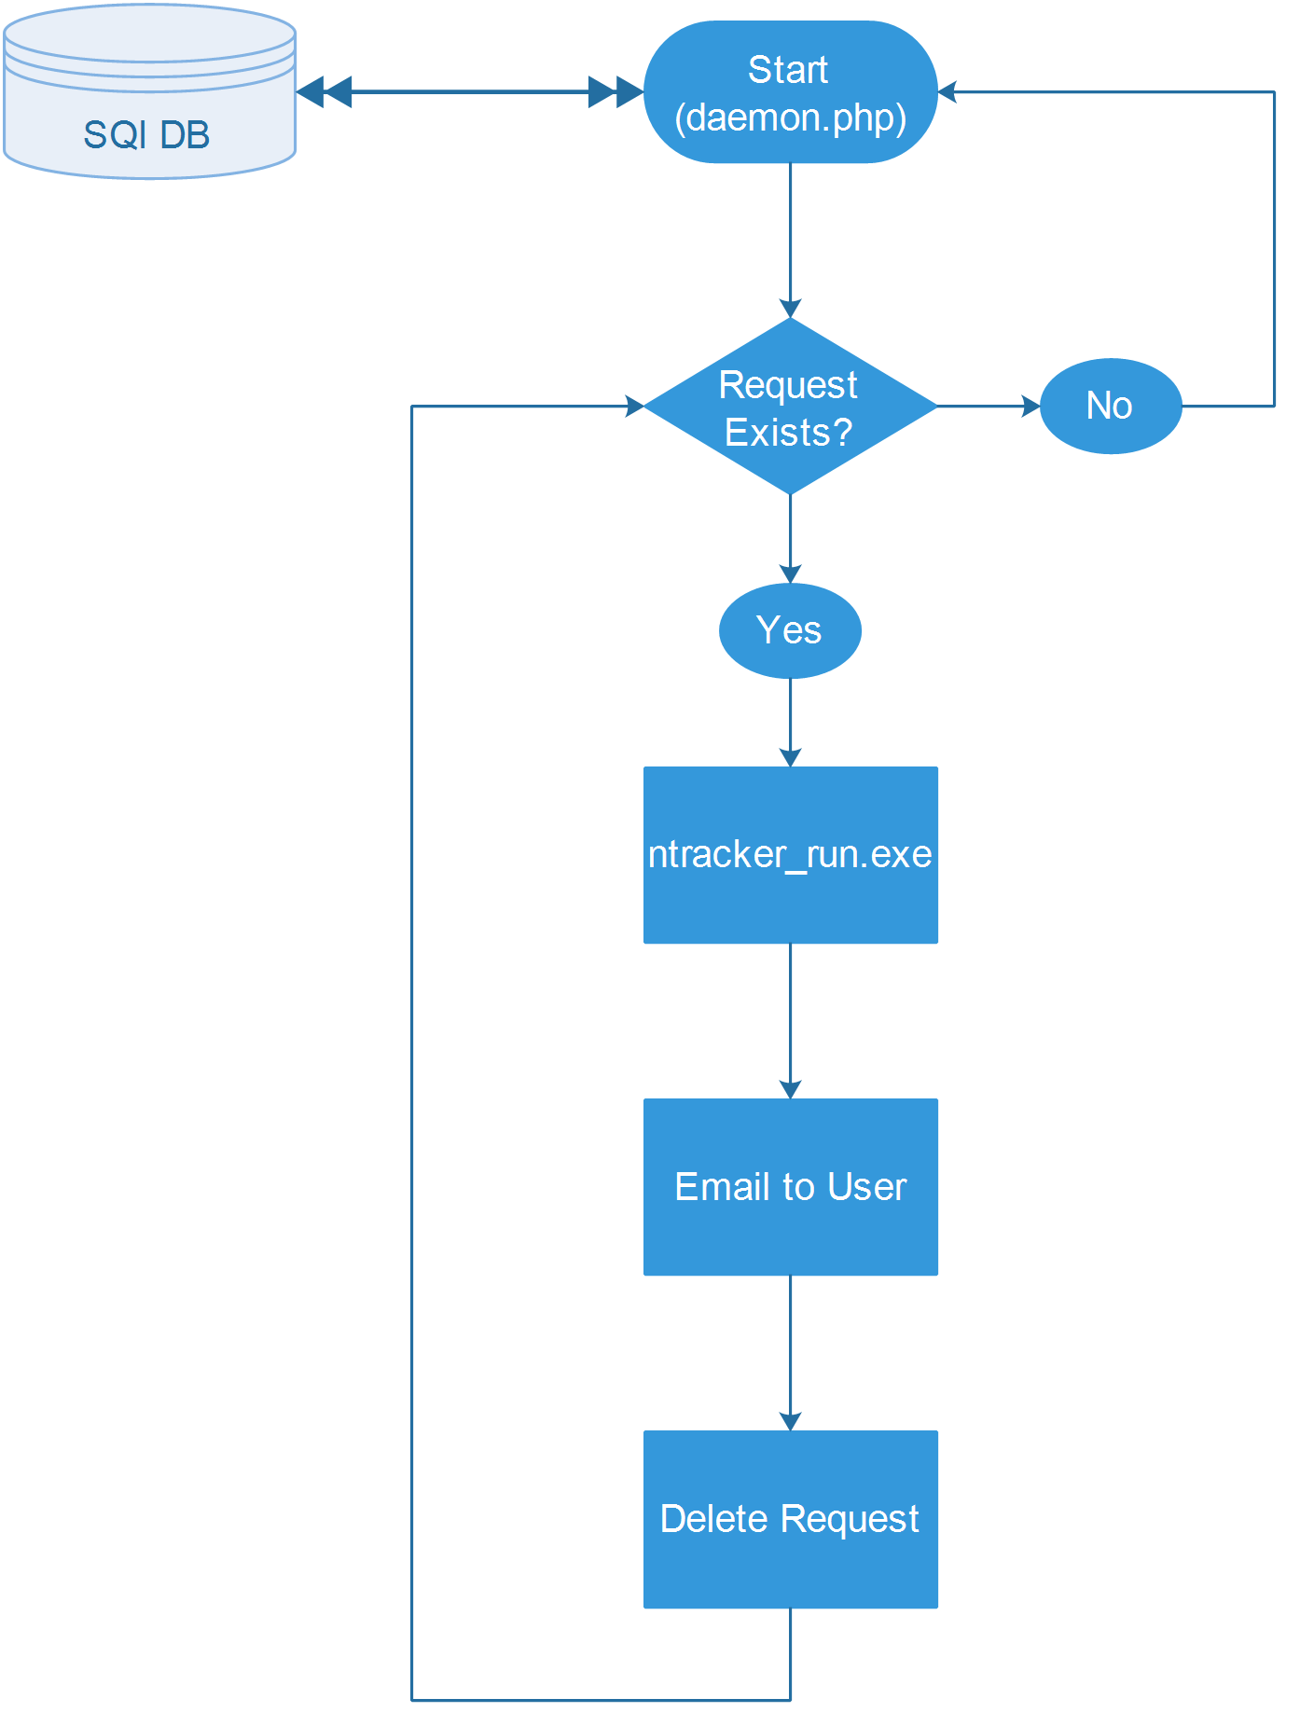

# **Description of Files**

The description of the different files used in the system is as follows:

## **Index.php**

This is the homepage of the online tool. A user can either sign in using an existing user id and password or sign up for a new account. This page directs to main.php after the user clicks on Login button. If Create Account is clicked, the required fields are shown for creating a new account. A successful new account registration will also direct the user to the main.php.

## **Mysql.php**

It contains information about the database in which the existing user information is stored (“$db_name”). It also contains database login and password. Additionally, names of the tables used to store the parameters submitted by the clients (“$tbl_name1”) are also included. If daemon.php finds that the table doesn’t exist, it will automatically create one. If you want to change the table structure, you can modify the “daemon.php” file.

$sql="CREATE TABLE IF NOT EXISTS $tbl_name1 (

timestamp varchar(50) DEFAULT NULL,

email varchar(255) DEFAULT NULL,

latitude float DEFAULT NULL,

longitude float DEFAULT NULL,

month tinyint(4) DEFAULT NULL,

day tinyint(4) DEFAULT NULL,

year int(4) DEFAULT NULL,

myusername varchar(255) DEFAULT NULL,

id int(10) unsigned NOT NULL AUTO_INCREMENT,

emonth tinyint(4) DEFAULT NULL,

eday tinyint(4) DEFAULT NULL,

eyear int(4) DEFAULT NULL,

ndate date DEFAULT NULL,

nrate int(5) DEFAULT NULL,

ndepth tinyint(4) DEFAULT NULL,

second_date date DEFAULT NULL,

second_rate int(5) DEFAULT NULL,

second_depth tinyint(4) DEFAULT NULL,

third_date date DEFAULT NULL,

third_rate int(5) DEFAULT NULL,

third_depth tinyint(4) DEFAULT NULL,

cultivar text DEFAULT NULL,

rmi int(10) DEFAULT NULL,

PRIMARY KEY (id)

) ENGINE=InnoDB DEFAULT CHARSET=latin1";

### Database fields

Following are the fields in database (ntrack_params and ntrack_log on \\swsrsetserver) to store the query request parameters:

Timestamp 🡪 for storing time and date of the request.

Email 🡪 for storing email of request submitter. Needed to send the output files.

Latitude 🡪 latitude of the location where N tracking in required

Longitude 🡪 longitude of the location where N tracking in required

Month 🡪 Planting month

Day 🡪 Planting day

Year 🡪 Planting year

myusername 🡪 Username

emonth 🡪 End month for calculations

eday 🡪 End day for calculations

eyear 🡪 End year for calculations

ndate 🡪 First nitrogen application date

nrate 🡪 First nitrogen application rate

ndepth 🡪 First nitrogen application depth

second_date 🡪 Second nitrogen application date

second_rate 🡪 Second nitrogen application rate

second_depth 🡪 Second nitrogen application depth

third_date 🡪 Third nitrogen application date

third_rate 🡪 Third nitrogen application rate

third_depth 🡪 Third nitrogen application depth

cultivar 🡪 Name of the corn cultivar, either selected from the dropdown list or entered in the text field

rmi 🡪 Cultivar’s relative maturity index (RMI) in number of days.

## **Register.php**

This file is called when the user creates a new account through index.php. It performs data checks on the user’s inputs and if everything is correct, the information provided in the signup form is stored in the database for storing the login information. After successful registration, this page directs the user to main.php.

## **main.php**

Using this page, user can submit the N-tracking requests. User provides the simulation parameters including the corn cultivar used, planting and simulation end dates, fertilizer applications information, and latitude and longitude of the desired location. It must be ensured that the following rules are followed or else, the request submission will fail.

**Checks on user input data:**

1. If user choses to add new cultivar:
   1. Cultivar name cannot be blank
   2. Cultivar’s RMI cannot be blank
2. Plant date, end date, nitrogen date, nitrogen rate, nitrogen depth, Latitude, and Longitude cannot be blank
3. Nitrogen application dates should be in mm/dd/yy(yy) format, e.g. 04/14/16 or 04/14/2016.

**Check on Data Ranges:**

1. End date cannot be beyond 365 days of the planting year, e.g. for planting date 04/15/2016, user cannot select end date in 2017 after 05/15/2016, and so on.
2. End date cannot be in the future (after the current date).
3. Fertilizer application cannot be more than six months before planting date for fall applications
4. Fertilizer date cannot be after simulation end date.
5. Latitude and Longitude cannot be outside of Illinois boundary

The location can be selected either from the Google-maps API shown in the form or it can be inserted manually in the text fields. **Note that** **this tool works only for the Illinois region because the server has soil data for the Illinois region only.** After the user specifies the simulation parameters and submits the request, the user’s request is added to the queue. User will be redirected to confirmation.php, and the request will be processed on a First-In-First-Out basis.

## **daemon.php**

This is the heart of the system. It runs as a background process, and can be customized and configured in the task scheduler. It retrieves the user request parameters from the database and begins the execution of the main N-tracking program (ntracker_run.exe) using those parameters.

### Source Code Location

The source codes of the program (ntracker_run.exe) is located in the following directory on \\swsrsetserver:

C:\Program Files (x86)\NMSU\RSET\wwwroot\ntrack\ ntracker.rar

The code may also be downloaded from the link:

// Add a link here (if desired, although not recommended)

### The Program (ntracker_run.m) Structure

#### Summary

A batch file daemon.bat located in “C:\Program Files (x86)\NMSU\RSET\wwwroot\ntrack” calls the file daemon.php which in turn calls the program exe file (ntracker_run.exe) whenever there is a new request in the SQL database to prepare input data, run DSSAT simulation, and sends output back to the user as an email. The source code of the program is located in ‘C:\Users\Administrator\My Documents\MATLAB’ with the main file being ‘ntracker_run.m’.

#### Description

The source code of the exe file contains the following functions. The functions appear in order as they are called:

* Ntracker_run.m
  + Import_userdata.m
  + Soil.m
  + Weather.m
  + Process_fileX.m
    - Cultivar_exists.m
    - Write_cultivar.m
      * Calculate_params.m
    - Get_index.m
    - Get_file_id.m
  + Plot_dssat.m
    - Jl2normaldate.m

Some of the main functions and their roles are described in the following sections.

##### ntracker_run.m:

This function is the main entry point for the N-tracking program. The function defines hard coded directories for the following:

1. NWS daily weather data (main directory, e.g. ‘E:/2017Data/NWS/’)
2. DSSAT exe file (default is, 'C:/DSSAT46/')
3. Soil file (processed from gSSURGO, currently located on \\swsrsetserver in the directory 'E:/SunY/Soildata/IL_Soil_Data_Base_Das.txt')

It then passes all the user defined variables to the import_userdata.m (described below) for preparing data to be used to further steps. The following functions are called by the ntracker_run.m and are presented in a sequence.

##### import_userdata.m:

This function creates a new structure with all the user data in DSSAT’s acceptable format. User defined input data that was stored in the SQL database is processed into the program useable format and it outputs a structure with the parameters that will be used in later functions. The followings are the processes that are performed in this function:

1. Planting date, end date, and fertilizer application dates are converted to ‘yyddd’ format, where ‘yy’ is the two digits year and ‘ddd’ is the three-digit number for day of the year. For example, 05/15/2017 will be converted to 17135 because May 15 is the 135th day of the year.
2. Nitrogen application rates are converted from lbs/acre to kg/ha.
3. Stores cultivar name, rmi, lat/ long as is in a structure object.

##### soil.m:

The soil function has twofold role. In the first part, the function uses lat/long coordinates to locate soil’s Map Unit Key (MUKEY) of the selected location. This is done by utilizing R’s spatial analysis capabilities. MATLAB’s soil function runs the R code to get the corresponding MUKEY. The source code for this is located at 'C:\Users\Administrator\Documents\R\extract_mukey.R' on \\swsrsetserver. This code searches the MUKEY for the provided location.

**Notice: This file needs MUKEY raster which is located on \\swsrsetserver (E:/SunY/Soildata/** **MapunitRaster_IL_10m1.tif). In addition, the ArcGIS needs to be installed on the system and the script will need to be update according to the current ArcGIS version installed on the system it is running on. To do that, open extract_mukey.R with any text editor and change the version according to the installed version on line 38. For example for ArcGIS 10.4, change the ArcGIS10.3 (in red) to ArcGIS10.4.**

**Line 38: rpygeo.env <-rpygeo.build.env(python.path="C:/Python27/ArcGIS10.3",…**

The MUKEY is used to search the soil file for the corresponding soil records, which is then used to generates a soil file (UI.SOL) in “C:\DSSAT46\Soil\”. Not all of the MUKEYs have corresponding records in the soil database, so if the program fails to find a record against a MUKEY, it’ll search for the closest soil record to the user’s location and use that information to write the soil file.

The format and variable explanation in soil file (UI.SOL) can be found here:

<http://rsetserver.sws.uiuc.edu/docs/N%20Tracking%20Project/Soil%20Data/Champaign%20soil%20data%20sample.xlsx>

Next, the program decides the simulation start date. It is based on either planting date or first nitrogen application date. The program sets simulation date to 5 days prior to the planting or fertilizer application date, whichever is earliest. This simulation start date is also used in weather module to prepare daily weather data file for DSSAT simulations.

##### weather.m:

Based on the simulation start and end dates for the user defined location, the weather module generates a weather file (UINT1601.WTH) in “C:\DSSAT46\Weather\” for the entire simulation period. For each day of each month of each year within the simulation period, the program reads a csv file ‘yyyy-mm-dd.csv’ inside of each day’s folder and find a record corresponding to the user’s selected location and writes that information to the DSSAT’s weather file, UINT1601.WTH. This continues until the simulation end date is reached.

The file structure and explanation of each variable in the weather file (UINT1601.WTH) is explained in the doc file “DSSAT Input Weather Data Format.docx” that can be downloaded from:

<http://rsetserver.sws.uiuc.edu/docs/N%20Tracking%20Project/Weather%20Data/WEATHER%20DATA%20file%20format.docx>

In addition to soil and weather data, DSSAT requires information about initial soil conditions at the site where simulations are needed to be run. This information however, is not readily available. The N-Track program has collected initial conditions for six sites scattered across Illinois and therefore complete DSSAT input files (FileX) exists only for these six sites. The program is set to use the initial conditions from one of the six sites that is nearest to the user’s location. This can be changed later as more data is available in future. The FileX from the nearest station is used in the process_filex.m module to update the soil, weather, location information, along with planting date, end date, and fertilizer applications in the FileX.

##### process_filex.m:

This function will update required information in the DSSAT’s input file (FileX). The information includes cultivar ID and name, soil and weather information, lat/long, fertilizer application, planting date, and simulation starting date among other. The output from this function is a file ready to be used in the DSSAT.

The processes performed in this module include:

1. Checking existence of the selected cultivar in the database. If it is a new cultivar, a new record will be added to the cultivar file (C:/DSSAT46/Genotype/MZCER046.CUL).
2. Update the cultivar ID and name in the FileX
3. Update soil and weather IDs in the fileX
4. Add latitude and longitude to the FileX
5. Update fertilizer application(s) dates, rates and depths
6. Update planting and simulation start dates
7. Update initial condition date
8. Update simulation end date (harvest date)

The FileX’s file structure and explanation of variables are provided in the help document that can be accessed from the following link:

<http://rsetserver.sws.uiuc.edu/docs/N%20Tracking%20Project/FileX%20format.docx>

The program calls DSSAT’s exe file to run the simulations using the updated FileX. The output of the simulations are stored in the default DSSAT directory (‘C:\DSSAT46\Maize\’)

##### Plot_dssat.m:

This function reads in the output file ‘SoilNi.OUT'’ from 'C:\DSSAT46\Maize\ and calculates average N concentrations in 0-1, 1-2, and 0-2 ft depths and plots the output in the user’s folder in the ntrack root folder.

Finally, daemon.php generates an email with user’s inputs and a link to the output file and sends the email to the user at their registered email address.

#### It is an online tool for tracking real-time (daily frequency) soil nitrogen availability (lbs Nitrogen/acre) in cornfields for the user-defined location in Illinois. Decision Support System for Agro-technology Transfer (DSSAT), version 4.6, is used in combination with USDA gSSURGO soil database, and daily NWS weather data (Real-Time Mesoscale Analysis) to simulate soil nitrogen dynamics. Users are asked to provide information about location (latitude/longitude, or click on Googlemap to choose a location), corn cultivar being used (or default one), planting date and fertilizer application date(s) and amount(s), and simulation end date (default is current date). The information is sent to the server where the program prepares soil and weather files corresponding to the user’s location. DSSAT simulations are then run for the selected simulation duration and an output is generated in the form of an email to the user with times series of soil Nitrogen concentrations (lbs Nitrogen/acre) at two depths (0-1 and 1-2 feet) over the requested period from first application of nitrogen or from planting date (whichever is earliest) to the simulation end date.

## **Instructions for using the online tool**

#### ****Note:**** This tool works for Illinois region only. N-Tracking is only available from Nov 1st, 2015 based on the current availability of NWS weather data. Once a request is successfully submitted, simulations will run and the output will be sent to the user as an email.

#### Please follow the following steps to use the N-tracking online tool

1. Go to the tool's [login page](http://swsatmossci.ad.uillinois.edu/ntrack/index.php)
2. If you have an account, use the login info to log into the system. Else, register a new account by clicking on the “Create Account” tab.
3. If you want to log out, click on the “Logout” link. If you want to submit a simulation request, proceed to the following steps.
4. After you have been directed to the requested page, input the following parameters:
   * Select a corn **Cultivar** from the dropdown list or choose “add new” to add a new cultivar, if not provided in the list.
     + If adding a new cultivar, cultivar name and relative maturity index (RMI) values (in days) must be provided for the new cultivar. The program will use RMI values to compute required cultivar parameters.
   * Input the **Planting Date** and desired simulation **End Date** for the simulation request.
     + Due to limited past weather data, earliest simulations can be run for 2016 growing season. Weather data prior to 2016 growing season will be added later
     + Simulation end date cannot be before the planting date, or into the next year (no multi-years simulations).
   * Input the amount of fertilizers applied at the location for the current growing period. The tool allows up to three **Nitrogen Applications**for a growing year. Select the number of fertilizer applications from the dropdown menu and provide the following information for each application.
     + Fertilizer Application **Date** in mm/dd/yy(yy) format, e.g. 04/14/16 or 04/14/2016
     + **Rate** at which fertilizer was applied in pounds per acre
     + Fertilizer application **Depth**. Use the default value if not known
     + Multiple fertilizer applications should be entered in increasing order with earliest application first and so on
     + No fertilizer application is allowed after the simulation end date
     + **Note:** If no fertilizer was applied, select a date within simulation period and change the fertilizer rate to 0
   * **Latitude** and **Longitude:** Select the location at which nitrogen tracking is desired. This can be done either by clicking at the desired location in the interactive Google map or by typing in the coordinates in the respective fields.
   * Finally, click on the **Submit** button. Your request will be processed, and an email will be sent containing the results (Fig. 1). The results include a graph of soil nitrogen availability (lbs/acre) as it changes during the simulation period in two soil depths - 0-1 and 1-2 feet, and total nitrogen concentrations in both depths.

[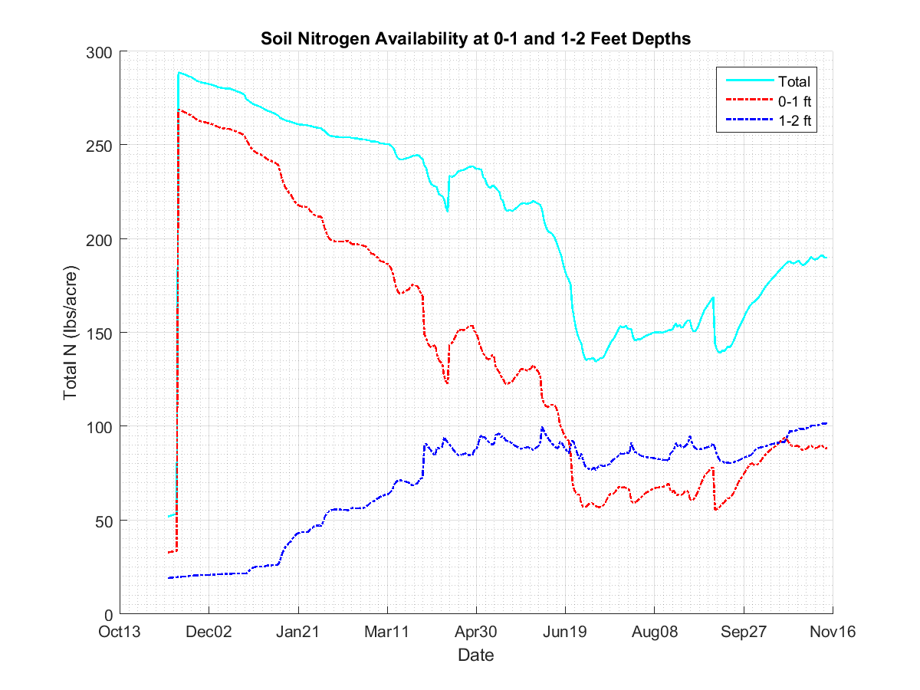](http://rsetserver.sws.uiuc.edu/ntrack/img/sample.png)

**Figure 1. Sample output sent to the user. Click to enlarge**

#### If you have any questions about the tool, please email: