Problem: to make matlab contourf look like that on Google earth.

Solution: Go to matlab file exchange, which has a lot of resources:

<http://www.mathworks.com/matlabcentral/fileexchange/>

Search “google map” or “google earth”, there are many interesting packages. I use “plot_google_map”, which can be downloaded from here:

<http://www.mathworks.com/matlabcentral/fileexchange/27627-plotgooglemap>

on the upper-right corner.

The function plot_google_map has many interesting options such as show map type as “roadmap” or ”sitellate” or ”hybrid”. Overlay the contour directly on google earth and generate kmz file is also possible.

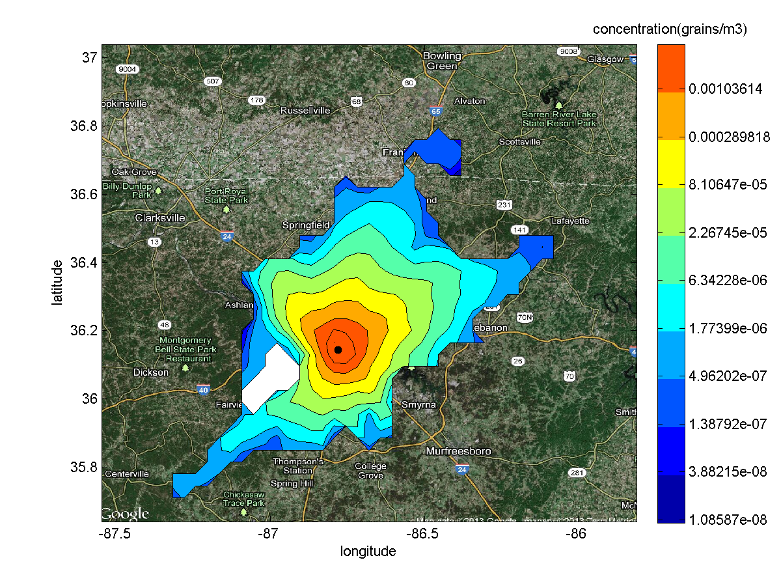

Code attached:

function depconoutcontour(userid, filename, lat, long)

close all;

A=importdata(['.\', userid, '\', filename, 'output_data.txt']);

A=A.data;

min1 = min(A);

max1 = max(A);

lat = str2num(lat);

long = str2num(long);

h1 = figure();

set(h1, 'Visible', 'off');

x = min1(4):((max1(4)-min1(4))/40):max1(4);

y = min1(3):((max1(3)-min1(3))/40):max1(3);

[X,Y]=meshgrid(x,y);

Z=griddata(A(:,4),A(:,3),log10(A(:,5)),X,Y);

z1=min(min(Z)); z2=max(max(Z));

color_range = z1:((z2-z1)/11):z2;

Contours=10.^color_range;

contour(X,Y,Z,color_range); %,color_range

h=contourcmap('jet',...

'Location', 'vertical', ...

'TitleString', 'deposition');

%caxis([z1,z2]);

g=colorbar('YTick',color_range,'YTickLabel',Contours);

title(g,'deposition(grains/m2)')

xlabel('longitude');ylabel('latitude');

hold on;

plot(long,lat,'k.','MarkerSize',20);

XL = xlim; YL = ylim;

rect = [YL(2), YL(1), XL(2), XL(1)];

% export_overlay(gcf, ['deposition','.kmz'], rect);

% return;

plot_google_map('maptype','hybrid','APIKey','AIzaSyDMSjokr-3WVHSYtZeW5xM2gI6uO8BkiMI');

fileextension='.pdf';

name=['.\', userid, '\', filename, 'deposition',fileextension];

print('-dpdf',name);

fileextension='.png';

name=['.\', userid, '\', filename, 'deposition',fileextension];

print('-dpng',name);

delete(h);

h1 = figure();

set(h1, 'Visible', 'off');

T=log10(A(:,6));

Z=griddata(A(:,4),A(:,3),T,X,Y);

z1=min(min(Z)); z2=max(max(Z));

color_range = z1:((z2-z1)/11):z2;

Contours=10.^color_range;

contourf(X,Y,Z,color_range); %,color_range

h=contourcmap('jet',...

'Location', 'vertical', ...

'TitleString', 'concentration(grains/m3)');

g=colorbar('YTick',color_range,'YTickLabel',Contours);

title(g,'concentration(grains/m3)')

xlabel('longitude');ylabel('latitude');

hold on;

plot(long,lat,'k.','MarkerSize',20);

plot_google_map('maptype','hybrid','APIKey','AIzaSyDMSjokr-3WVHSYtZeW5xM2gI6uO8BkiMI');

fileextension='.pdf';

name=['.\', userid, '\', filename, 'concentration',fileextension];

print('-dpdf',name);

fileextension='.png';

name=['.\', userid, '\', filename, 'concentration',fileextension];

print('-dpng',name);

delete(h);

h1 = figure();

set(h1, 'Visible', 'off');

Z=griddata(A(:,4),A(:,3),log10(A(:,7)),X,Y);

z1=min(min(Z)); z2=max(max(Z));

color_range = z1:((z2-z1)/11):z2;

Contours=10.^color_range;

contourf(X,Y,Z,color_range); %,color_range

h=contourcmap('jet',...

'Location', 'vertical', ...

'TitleString', 'outcrossing');

g=colorbar('YTick',color_range,'YTickLabel',Contours);

title(g,'outcrossing')

xlabel('longitude');ylabel('latitude');

hold on;

plot(long,lat,'k.','MarkerSize',20);

plot_google_map('maptype','hybrid','APIKey','AIzaSyDMSjokr-3WVHSYtZeW5xM2gI6uO8BkiMI');

fileextension='.pdf';

name=['.\', userid, '\', filename, 'outcrossing',fileextension];

print('-dpdf',name);

fileextension='.png';

name=['.\', userid, '\', filename, 'outcrossing',fileextension];

print('-dpng',name);

delete(h);

end

Note: export_overlay.m is for KMZ contours. Sample outputs IN Horseweed folder on SWSAtmosphersci server: deposition.kmz, output.kmz