Open the command prompt and change the directory to the folder that has the perl file

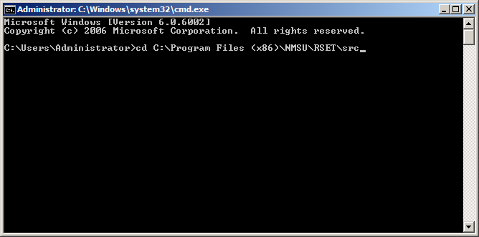

Then type the command – “perl replace.perl” and press enter. The perl file will be executed

